

CS710S Handheld Sled RFID Reader Bluetooth and USB Byte Stream API Specifications

Version 1.18

2026 01 27

Chapter 1: Release Notes

Dates | Release | Description
2023 2 16 | 0.97 | Pre-Release
2023 5 30 | 0.101 | Miscellaneous changes
2023 07 31 | 0.102 | -9 channels
2023 10 05 | 1.0 | First Release
2024 01 25 | 1.1 | Add 0x10A7 and 0x10A8 commands for access inventory (protected mode inventory) of Impinj tag ICs
2024 01 25 | 1.2 | Modify the On Time in country enum table
2024 06 13 | 1.3 | MultibankReadConfig register change
2024 08 01 | 1.4 | Add some error codes
2024 08 20 | 1.5 | Update Taiwan frequency plan
2024 09 25 | 1.6 | Update Error Code description for 0x000F and 0x0012
2024 09 25 | 1.7 | Update Error Code description for 0x000F and 0x0012
2024 09 26 | 1.8 | Update Error Code description for 0x000F and 0x0012
2024 09 26 | 1.9 | Update Error Code description for 0x000D
2024 09 26 | 1.10 | Update Error Code 0x0FFF to 0x00FF
2025 03 06 | 1.12 | CustomRegulatoryTime register change  Add PowerBoost register
2025 04 03 | 1.13 | Add more OEM registers  Add Bluetooth HID mode on/off commands and registers
2025 04 24 | 1.14 | Updata country enum table for China  Add more prefix and parameters for HID configuration (see A.3.1: CSL RFID Registers Summary Table)
2025 05 16 | 1.15 | Clear some typos
2025 07 07 | 1.16 | Duplicate Elimination Time Window, different definition for normal mode and HID mode
2025 10 16 | 1.17 | Modify country table for South Africa and for Thailand
2026 01 27 | 1.18 | Change Algeria 2 country code compatibility to NA, no need to implement

Chapter 2: Content

Chapter 1: Release Notes 2
Chapter 2: Content 3
Chapter 3: Introduction 5
Chapter 4: Interfaces to CS710S 6
4.1 Bluetooth Connection Details 7
4.1.1 CC2652 Family Bluetooth IC DLE Configuration 21
4.2 USB Connection Details 25
Chapter 5: LED definitions 26
Chapter 6: Push buttons Definition 27
Chapter 7: API Set Definition 28
5 API Format 28
7.2: Header of RFID Reader Commands 30
7.3: Header of Barcode Reader Commands 31
7.4: Header of Special Notifications 32
7.5: Header of ATMEL IC Commands 33
7.6: Header of Bluetooth IC Commands 34
Chapter 8: Payload – RFID Reader Commands 34
8.1 Downlink Payload 35
8.2 Uplink Payload 36
Chapter 9: Payload – Barcode Reader Commands 37
9.1 Downlink Payload 38
9.2 Uplink Payload 39
9.2.1 Uplink Barcode Payload Format 39
Chapter 10: Payload – Special Notifications 39
10.1 Downlink Payload 41
10.2 Uplink Payload 42
Chapter 11: Payload – ATMEL IC Commands 43
11.1 Downlink Payload 43
11.2 Uplink Payload 44
Chapter 12: Payload – Bluetooth IC Commands 45
12.1 Downlink Payload 45
12.2 Uplink Payload 46
Chapter 13: Factory Default Settings 47
Appendix A – CSL Ex10 Based RFID Command Specification 48
A.1 Introduction 48
A.1.1 Communication Types Introduction 48
A.1.2 Program Flow Introduction 51
A.1.3 Packet Format Introduction 52
A.1.4 Tag Caching and Duplicate Elimination Rolling Window 53
A.2 CSL Commands 54
A.2.1 Write Register Command 55
A.2.2 Read Register Command 57
A.2.3 Operation Commands 59
A.2.4 Administration Commands 63
A.3 CSL Registers 66
A.3.1 CSL RFID Registers Summary Table 66
A.3.2 CSL RFID Registers Details 72
A.3.3 EPC Commands Refresh 75
A.3.4 CSL Ex10 Country Enum Table 78
A.3.5 Reader Mode Table 86
A.4 CSL RFID Uplink Packets 87
A.4.1 CSL RFID Uplink Packets Summary Table 88
A.4.2 CSL RFID Uplink Packets Details 90
Appendix B – Error Codes 99
Appendix C: Barcode Reader Command Sequence Examples 100
C.1 Pre-setup of Barcode Reader 100
C.2 Normal Operation of Barcode Reader 101
Appendix D – How to Choose Reader Modes 102
Appendix E – Session 105
Appendix F – Tag Population and Q 106
Appendix G – Query Algorithm 107
Appendix H – Target 108
Appendix I – Security 109
Appendix J – Tag Focus 111
Appendix K – Models & Regulatory Regions 112
Appendix L – CRC Table/Compute Codes 113

Chapter 3: Introduction

CSL E710 IC Based CS710S, is a Bluetooth or USB controlled RFID handheld reader sled. The sled allows the mounting of popular smart phones such as Android phone and iPhone, or iPod, onto the top; or connecting via USB from a PC or embedded system. One can also connect via Bluetooth from a Windows 10 laptop to it. An application inside the smart phones, downloadable free of charge from corresponding stores (Android Market or Apple App Store) will send commands via Bluetooth to the reader sled and operate the RFID reader module, the barcode module, the LEDs inside. Likewise, an application in the PC or embedded system can send commands down via USB to the CS710S. The App in the smart phone or the PC will also handle the display of data for interactive use by the operator, plus transferring of data out to the Internet Cloud.

The data collected by the smart phone App will contain the following:
- RDID tag data
- Barcode data

The user can further add functionalities to the application by developing their own applications based on the source codes of the smart phone App or the PC App, which is freely available from Convergence Systems Website.

This document describes the Bluetooth and USB Byte Stream API set. The CS710S can be controlled via a USB cable by a PC or any embedded system, sending byte stream down to CS710S, and with CS710S responding back via the USB cable in a byte stream manner. The CS710S can also be controlled via Bluetooth by iPhone, iPAD, Android phone, Windows 10 PC with Bluetooth BLE 5.0 connectivity, sending byte stream down to CS710S, and with CS710S responding back via Bluetooth in a byte stream manner. The following chapters define this byte stream interface. On the PC or embedded system platform, the user can employ any language: C#, Objective C, Swift, Java, Python, machine language, etc.

Chapter 4: Interfaces to CS710S

For CS710S, the commands can be fed in via 2 physical interfaces:

- Bluetooth BLE 5.0/5.1/5.2 (BLE stands for Bluetooth Low Energy)
- USB

These are all byte stream commands.

There are 5 different groups of commands and replies/notifications:

- RFID reader commands
- Barcode reader commands
- Special Notifications
- Silicon Lab IC commands
- Bluetooth IC commands

4.1 Bluetooth Connection Details
CS710S

Bluetooth
Slave
(Peripheral)
Mobile Phone:

Bluetooth
Master
(Central)

For Bluetooth 5.0/5.1 connection, i.e. Bluetooth Low Energy, GATT protocol is used for search and connection.

UUID is discoverable by the smart phone whenever the CS710S is flashing the Bluetooth LED.

When the mobile phone application “scan” for Bluetooth devices, the iOS OS will provide the application with the Reader’s Name, Device UUID (9802), Service UUID, etc.

CS710S’s specific Service UUID is 9900 and 9901. 9900 is for downlink service from smart phone to CS710S (write characteristic), 9901 is for uplink service from CS710S to smart phone (send notification)

iOS will use these 2 numbers (9900 and 9901) to generate “characteristic UUIDs” for the application to use.

In other words, CS710S reader uses Bluetooth Notification to send data back to smart phone.
CS710S/CS463 reader allows smart phone to use Bluetooth Write Charateristic to send data to the reader.

In theory, Bluetooth 5.0 has higher throughput than the previous Bluetooth 4.0 provided both the mobile phone and CS710S have implemented the proper configuration of Bluetooth 5.0.

However, the increase in data rate is not automatic and one needs to configure certain parameters to achieve highest rate.

If possible, the 2 Mbps (LE 2M PHY) should be configured on both sides. This will enable a raw data rate of 2 Mbps.

Bluetooth 5 & BLE: Achieving maximum throughput and speed | Novel Bits
https://interrupt.memfault.com/blog/ble-throughput-primer

The following is definition of connection event and connection interval:
- Connection Event – For BLE, exactly two devices are talking with each other in one connection. Even if data is not being exchanged, the devices must exchange a packet periodically to ensure the connection is still alive. The start of every period in which two devices can exchange information with one another is known as a Connection Event. A connection itself is thus a sequence of Connection Events.
- Connection Interval – The time between each Connection Event. The Connection Interval can be negotiated once the two devices are connected. Longer connection intervals save power at the cost of latency. Connection Intervals can range from 7.5ms to 4s.
Note that in BLE, the two devices are always talking back and forth. Even if only 1 side is mainly transmitting, the other side must send an ACK. Also, Inter Frame Space (IFS) of at least 150 µsec is needed. See below for a generic Bluetooth 4.0 connection event. Note that data length is at most 27 bytes in Bluetooth 4.0 packet. This is called the MTU (Maximum Transmission Unit). Of that MTU of 27 bytes only 20 bytes are for real payload. Data rate is 1 Mbit/sec. Therefore, each packet of 41 bytes requires 41 x 8 = 328 µsec to send.
The following is a Bluetooth 4.0 Link Layer packet:
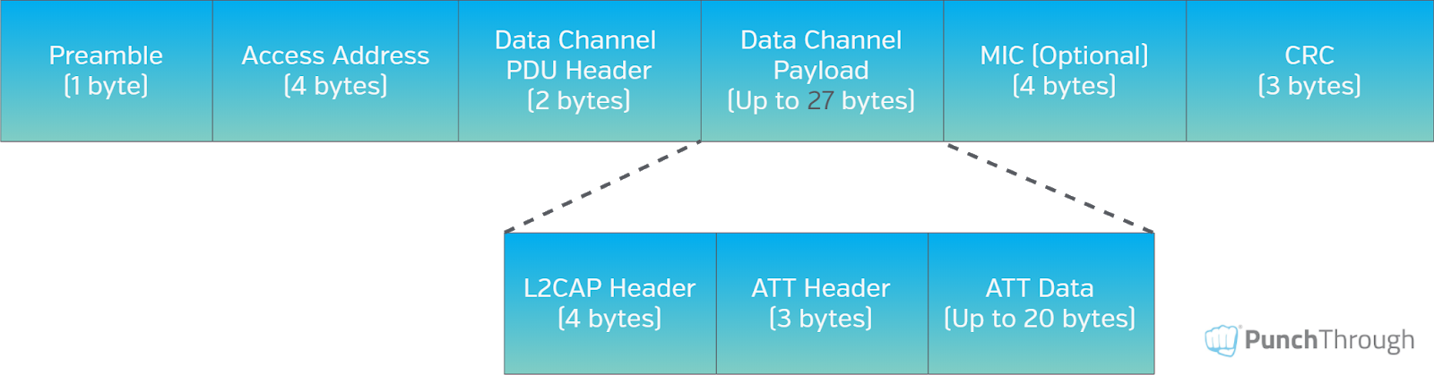
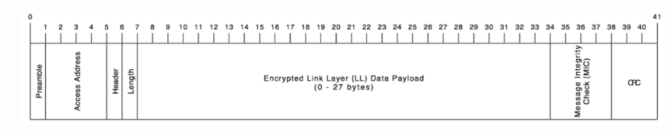
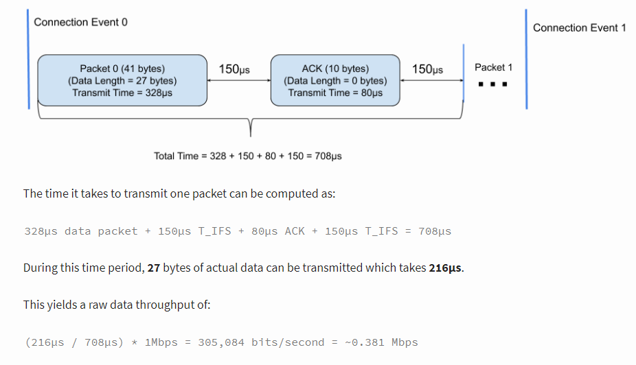
So how good is 305 Kbit/sec in terms of sending RFID tag data back to host processor?

Assuming each tag inventory packet is 42 bytes in length, i.e., 336 bits, then one can send 1,347 tag inventory data back to host processor.

In reality, this is not achievable.

The reason is that there is a limit on the number of packets you can send during each connection interval. For example, typically a 15 msec connection interval is allowed in mobile phone, and then within each connection interval, in Bluetooth 4.0, only 4 link layer packets are allowed with mobile phones in the market. Moreover, the 27 bytes are not all dedicated to payload. 7 bytes are used as header. So the throughput is really only about 20 bytes per packet.

After calculating that, the resultant throughput is 5333 bytes per second. Assuming 42 bytes per tag, then total tag per second is 126. In a laboratory environment and in an anechoic chamber, one may be able to reach 120 tags per second. In real world environment (from our experience of using that), due to Bluetooth jamming from nearby users, we can often only be able to send 30 tags per second. That is about one quarter of the time. In other words, the efficiency due to a real world noisy environment is only about 25%.

In Bluetooth 5.0, up to 16 packets are allowed per connection interval. Each packet can contain up to 251 bytes of payload, i.e., the MTU is 251 bytes. Of that Bluetooth 5.0 can send true payload of 244 bytes. Within that since CSL Bluetooth protocol needs to send a header of 8 byte, so the final tag related data (tag payload) that can be sent is 236 byte. As shown below, total bytes in a packet can be 265 bytes for 1M PHY and 266 bytes for 2M PHY. 265 bytes for 1M PHY takes up 2120 µsec, i.e., 2.12 msec. 266 bytes for 2M PHY takes up 1064 µsec, i.e. 1.06 msec.

Assuming connection interval is 15 msec, then maximum packets for 1M PHY can only be about 7, maximum packets for 2M PHY can be about 14. This number, however, needs to be configured in the firmware of the Bluetooth IC, and on the mobile phone side, if possible, by the driver.

Based on 2M PHY, then the total bytes transferred per second is 14 x 238 x (1 / 15 x 10⁻³) = 222,133.
Then the total number of tags is that number divided by 42, approximately 5,288 tags per second. Assuming there is a jamming resulting in only 25% successful transfer, then it is 1,322 tags per second.

Based on 1M PHY, then the total bytes transferred per second is 7 x 238 x (1 / 15 x 10⁻³) = 111,066. Total number of tags per second is 2,644. 25% jamming induced efficiency means 661 tags per second.

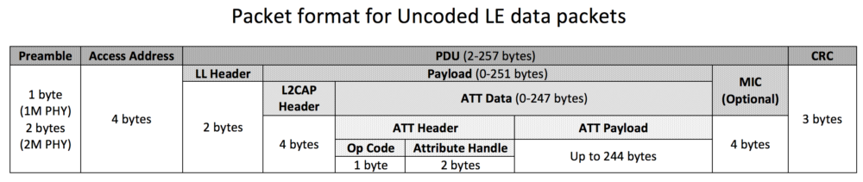

The above calculation assumes the mobile phone would dedicate all the time within a connection interval to actual LE data packets. This is HIGHLY UNLIKELY. The mobile phone needs to use the BLE time to handle other devices, check other broadcast packets nearby, etc. These maintenance stuffs will take up time as well. Hence it is highly unlikely a mobile phone would allocate all the time available for LE data packets. Some comment on the Internet shows developer trying to set up long LE data packets but was only able to get 1 to 2 of these long packets per 20 msec of connection interval. Some configurations are needed to get more packets.

Here is an example with Nordic Bluetooth device how to maximize the number of packets per connection interval:

How to determine the number of packets per connection interval – Nordic Q&A – Nordic DevZone – Nordic DevZone (nordicsemi.com)

Data Length Extension (DLE):

An example of a Connection event with Data Length Extension enabled:

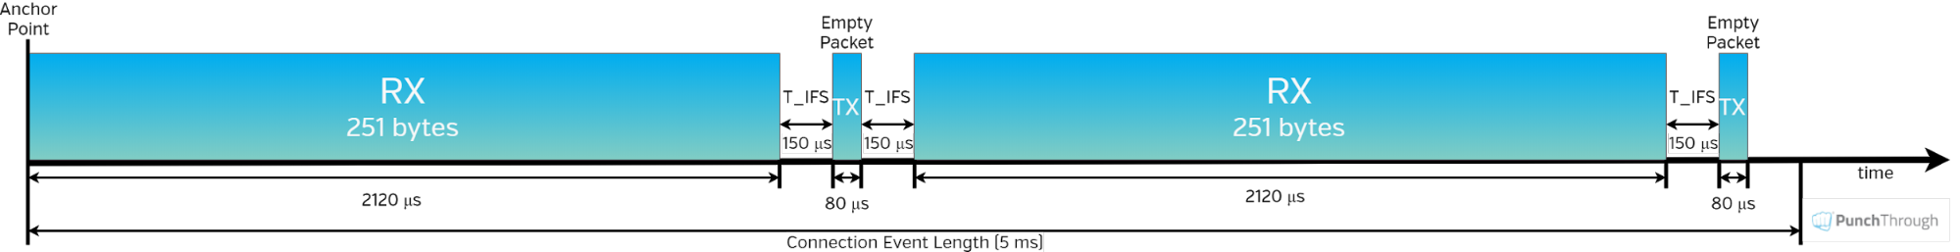

An example of a Connection Event without Data Length Extension:

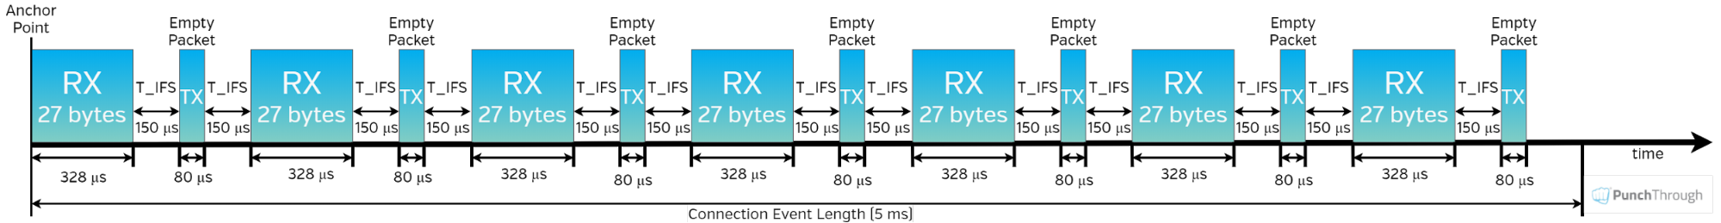

From the above 2 examples, it is clear that the efficiency is much higher when DLE is enabled. Less time is wasted in the acknowledgement (which is an empty packet), and less time is wasted in the Inter Frame Space (IFS), and less time is wasted in the overhead in each packet.

There is one parameter that is difficult to control: how much time within each Connection Interval would the Master allow Link Layer packets interchange to take place? Since this is decided in the Master, which in our case is the Mobile Phone, it is hard to control:

LL P
LL P
LL P
LL P
LL P
LL P

Connection Interval

The connection interval effectively determines how many packets can be sent during one connection event. The higher the value, the more packets can be sent in one connection event (up to a certain limit for some devices).

However, the number of packets per connection event depends on the device and BLE stack so it is limited and differs between devices and stack versions on a specific device. This value also depends on the operation of the device, so the radio may have to attend to other events and the number of packets sent per connection events may not reach the max allowed by the stack. For example, the number differs between iOS and Android and also changes depending on the version of the OS running on the device.

To achieve maximum possible transfer rate, one has to:

- Enable DLE,
- Configure highest possible MTU value = 251 (maximum possible is 251)
- Choose LE 2M PHY,
- Configure master to allow maximum number of packets per connection interval (maximum communication time) – depends on specific mobile phone and its OS.

Here are the details:

    - Enable DLE (Data Length Extension)

How to Enable DLE

How you’ll actually enable DLE in your project or application will depend on the chip, stack and SDK you’re running on, but at a lower level, the following needs to happen:

- Both the master and the slave must support the Bluetooth 4.2 specification or newer (see the LL_VERSION_IND exchange)
- Both the master and the slave must support the LE Data Packet Length Extension Link Layer feature (see the LL_FEATURE_REQ and LL_FEATURE_RSP exchange)
- Either master or slave must initiate the actual Data Length Update Procedure by sending an LL_LENGTH_REQ command, which must be responded to with an LL_LENGTH_RSP command to complete the procedure. The following four values are negotiated between the master and slave during the Data Length Update Procedure:
- connMaxTxOctets – the max number of payload bytes/octets that the stack can send in a single link layer data packet
- connMaxTxTime – the length of time in microseconds that the stack can be actively transmitting a single link layer data packet
- connMaxRxOctets- the max number of payload bytes/octets that the stack can receive in a single link layer data packet
- connMaxRxTime- the length of time in microseconds that the stack can be actively receiving a single link layer data packet

Either the Master or the Peripheral can initiate this DLE configuration. From the slave, which is the Texas Instruments Bluetooth IC, the TI API need to be used.

Note that the default value of CC2652 BT 5.0 stack is such the transmit direction and the receive direction are different. So that has to be carefully handled.
In the Peripheral, i.e., the Texas Instrument Bluetooth IC,

Take the following steps to configure the stack to support larger MTU values.
- Use LL_LENGTH_REQ to set the MAX_PDU_SIZE preprocessor symbol in the application project to the desired value to the maximum desired size of the L2CAP PDU size. The maximum is set by the following equation ATT_MTU=MAX_PDU_SIZE-L2CAP_HDR_SIZE
- Call GATT_ExchangeMTU() after a connection is formed (GATT client only). The MTU parameter passed into this function must be less than or equal to the definition from step 1.
- Receive the ATT_MTU_UPDATED_EVENT in the calling task to verify that the MTU was successfully updated. This update requires the calling task to have registered for GATT messages. See Registering to Receive Additional GATT Events in the Application for more information.
Though the stack can be configured to support a MAX_PDU_SIZE up to 255 bytes, each Bluetooth Low Energy connection initially uses the default 27 bytes (ATT_MTU = 23 bytes) value until the exchange MTU procedure results in a larger MTU size. The exchange MTU procedure must be performed on each Bluetooth Low Energy connection and must be initiated by the client.

In the master, which may be an Android phone, an iPhone, etc., appropriate APIs need to be invoked to configure the above.

- Configure MTU value = 251 (maximum possible is 251)

MTU value needs to be configured.

For mobile phone, to configure MTU:

For example, the following is the Android API that requests an MTU size for a given connection:

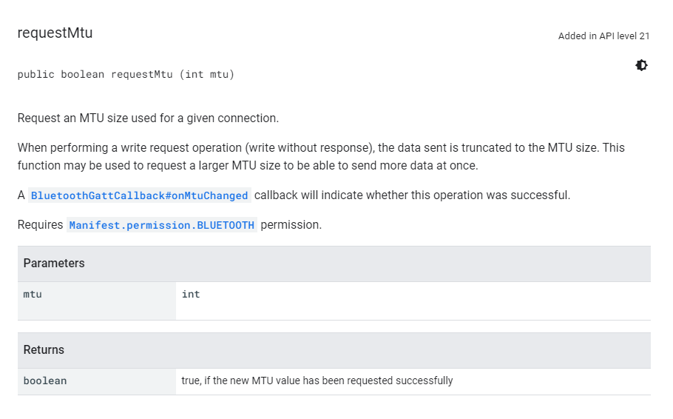

For CS710S side, for CC2652, to configure MTU:

One can initiate a GATT_ExchangeMTU() request. This will automatically try to achieve a biggest possible MTU. Or one can do a GATT_UpdateMTU() to try increase its size.

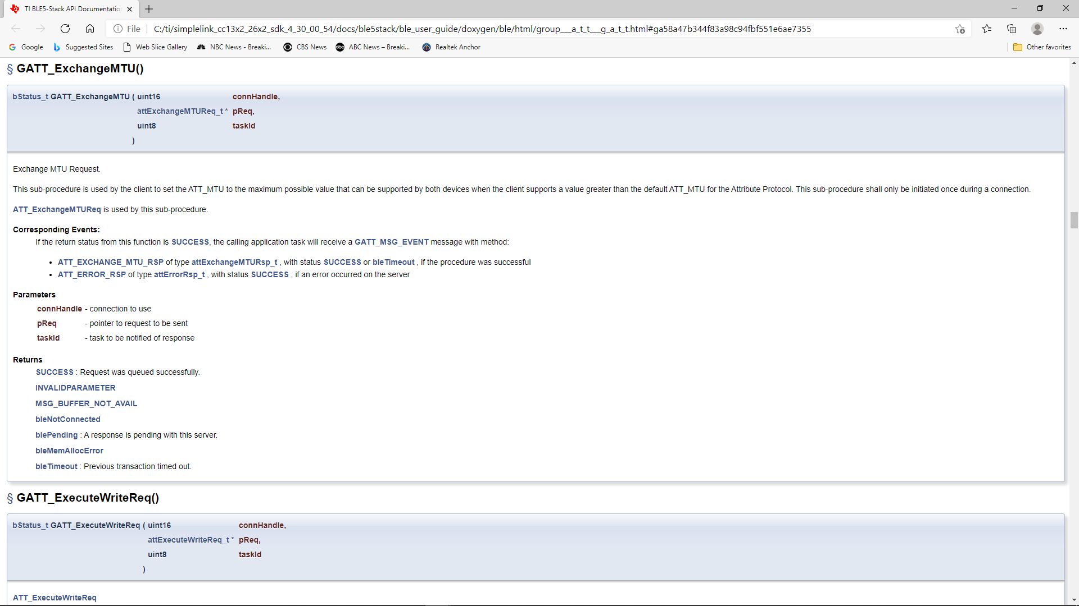

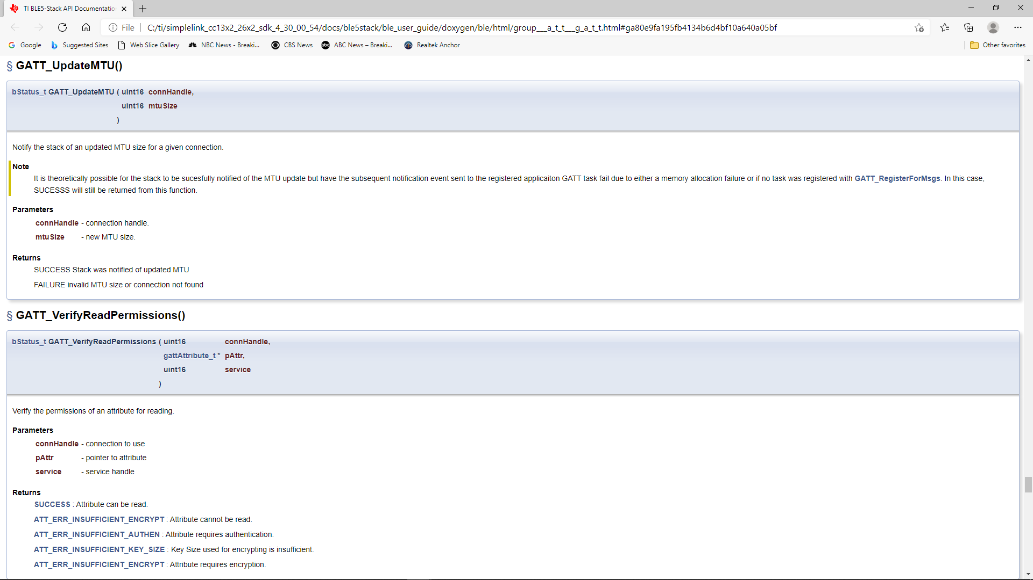

    - Choose LE 2M PHY,

With 2M PHY, the time for each LL packet becomes shorter by one half for the same number of bytes. This is useful both in overall transfer throughput and also better jamming avoidance.

In mobile phones:

In Android, you can invoke the following to set it to LE 2M PHY:

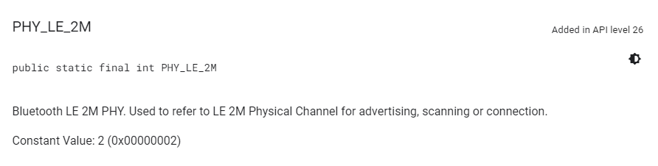

In Xamarin, you can invoke the following to set it to LE 2M PHY:

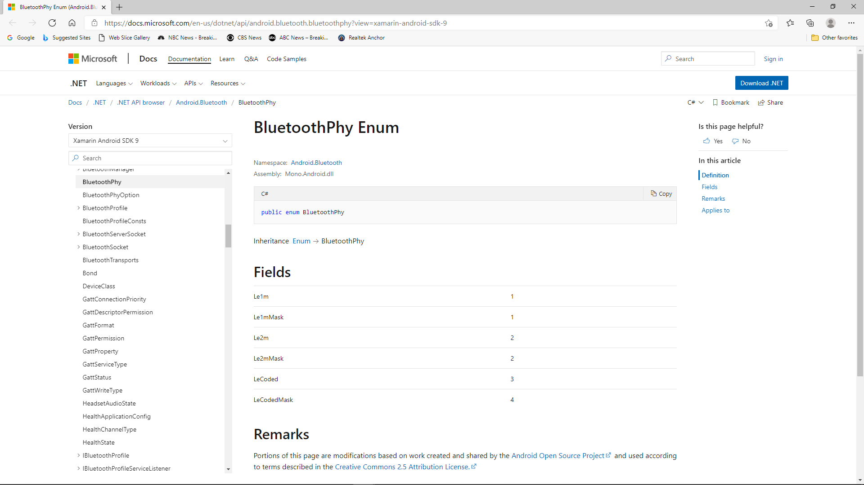

On the CS710S side, in CC2652,

You can set the default PHY:

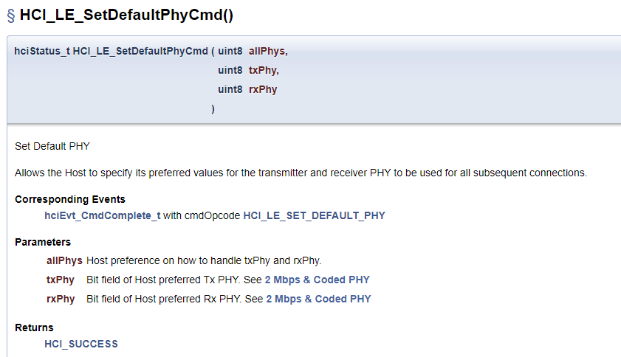

    - Configure master to allow maximum number of packets per connection interval (maximum communication time).

This is the most difficult part.

4.1.1 CC2652 Family Bluetooth IC DLE Configuration

The data length extension feature allows the LE controller to send data channel packet data units (PDUs) with payloads of up to 251 bytes of application data, while in the connected state. Furthermore, a new PDU size can be negotiated by either side at any time during a connection.

Previously, the controller’s largest data channel payload was 27 bytes. This Feature increases the data rate by around 250% when compared to Bluetooth Core Specification Versions 4.0 and 4.1 devices (if both devices support extended packet length and are configured properly).

The CC13x2 or CC26x2 has Data Length Extension enabled by default – allowing peer devices to utilize this feature with no application overhead.

DLE Update Procedure and Definitions
Default Application DLE Behavior
Utilizing DLE in the Application
Disabling DLE at Runtime
Interoperability with Legacy Peers
RAM Considerations when using DLE
DLE Update Procedure and Definitions
This section describes what is done from a controller perspective during a connection as well as terminology.

Once a connection is formed, the controller will behave in one of two possible ways:

If prior to the connection, the suggested PDU size and time are set to the defaults for both TX and RX (27B, 328 us) then the CC13x2 or CC26x2 will not initiate a data length exchange (i.e. a LL_LENGTH_REQ will not be sent).

If the peer device sends a LL_LENGTH_REQ then the controller of the device will send a LL_LENGTH_RSP corresponding to the default sizes of 4.0 devices autonomously.

Note

See Disabling DLE at Runtime for information on how to modify this behavior.

If prior to the connection, the PDU size or the maximum time for RX or TX are not default, then the LE controller of the device will use the LL_LENGTH_REQ and LL_LENGTH_RSP control PDUs to negotiate a larger payload size for data channel PDUs.

A data length update may be initiated by the host or performed autonomously by the controller. Either the master or the slave can initiate the procedure.

After the data length update procedure is complete, both controllers select a new data length based on two parameters: PDU size and time. The largest size supported by both local and remote controller is selected; time is taken into account to support different data rates. These parameters are defined below:

PDU size
The largest application data payload size supported by the controller. This size does not include packet overhead, such as access address or preamble.

Time
The maximum number of microseconds that the device takes to transmit or receive a PDU at the PHY rate. This parameter uses units of microseconds (us).

Each direction has a PDU size and time; in other words there is a Receive PDU size/time and a separate Transmit PDU size/time. A device can only influence a peer’s Receive PDU size/time by adjusting it’s own Transmit PDU size/time via the DLE Update Procedure.

Reference ([Vol 6], Part B, Section 5.1.9) of the Bluetooth Core Specification Version 5.1 for more information about the data length update procedure.

Reference ([Vol 6], Part B, Section 4.5.10) of the Bluetooth Core Specification Version 5.1 for information on the valid ranges for data PDU length and timing parameters.

Default Application DLE Behavior
This section describes the default behavior of the CC13x2 or CC26x2 due to the feature being enabled by default.

The controller defaults to using TX PDU sizes compatible with 4.0 and 4.1 devices. It uses 27 bytes as its initial maximum PDU size, and 328 us as the maximum PDU transmit time.

On the RX PDU size and time, the controller defaults to the maximum PDU size and the maximum PDU transit time for a LE Data Packet Length Extension enabled device. In other words, the RX PDU size will be 251, and the RX PDU transmit time will be 2120 us.

Note

As mentioned in DLE Update Procedure and Definitions, by default a LL_LENGTH_REQ control packet will be sent due to the RX max PDU size and max PDU transmit time not being default 4.0 PDU sizes and timings.

Utilizing DLE in the Application
This section describes how the application can influence the controller to use DLE for transmission of data at runtime.

The application can update the data length in two ways.

The application can set the connection initial TX PDU size or time to cause the controller to request the peer’s RX PDU size and time to change for every connection.
The controller can initialize the connection with the default values of 27 octets and 328 us, then dynamically negotiate the data length at a later time in the connection using HCI commands.
For maximum throughput, high layer protocols such as the BLE host should also use a larger PDU size (see Maximum Transmission Unit (MTU)). See Link Layer Buffers for more information how the link layer manages buffers and PDUs.

The following HCI commands can be used to interact with the controller related to the data length extension feature:

LE Read Suggested Default Data Length Command (HCI_LE_ReadSuggestedDefaultDataLenCmd())
LE Write Suggested Default Data Length Command (HCI_LE_WriteSuggestedDefaultDataLenCmd())
LE Read Maximum Data Length Command (HCI_LE_ReadMaxDataLenCmd())
LE Set Data Length Command (HCI_LE_SetDataLenCmd())
The above commands may generate:

LE Data Length Change Event
For example, to dynamically change the TX PDU size and timing, the command HCI_LE_SetDataLenCmd() during a connection. This will cause the LE controller to negotiate with the peer’s LE controller to adjust it’s RX PDU size and timing as described in DLE Update Procedure and Definitions.

Uint16_t cxnHandle; //Request max supported size
uint16_t requestedPDUSize = 251;
uint16_t requestedTxTime = 2120;

GAPRole_GetParameter(GAPROLE_CONNHANDLE, &cxnHandle); //This API is documented in hci.h

HCI_LE_SetDataLenCmd(cxnHandle, requestedPDUSize, requestedTxTime);
Note

For more information about these HCI commands and their fields, see the LE Controller Commands and Events sections ([Vol 2], Part E, Section 7.7-7.8) of the Bluetooth Core Specification Version 5.1. Additionally, the APIs for these commands are documented under BLE Stack API Reference.

4.2 USB Connection Details

USB HID library on the host platform is used. The protocol using USB connection as described in this document is only for CS710S.

Chapter 5: LED definitions

There are 7 LEDs on the CS710S device:

- Power on LED: Turn on whenever power switch turns on power
- Charging LED: Turn on whenever battery is being charged. Brighter when battery is more drained and charging current is higher.
- External Power LED: Turn on whenever external power is available and used.
- RFID LED: turned on continuous when RFID power is on. Flashes when tags are being read – (inventory started).
- Barcode LED: turned on continuous when BARCODE power is on. Flashes when barcodes are being read – (barcode reading started).
- Status LED: status of Atmel IC
- Bluetooth LED: status of Bluetooth – on (waiting for pairing), off, pairing, paired
      - When Bluetooth push button is pressed for 3 seconds, Bluetooth LED starts slow flashing, 1 second on, 1 second off. Unit is now ready for discovery and pairing by smart phone
      - During pairing, fast flash, 0.5 second on, 0.5 second off
      - When successful paired, Bluetooth LED changes to continuous on
      - Anytime when Bluetooth is on (Bluetooth LED either slow flashing or fast flashing or continuous), by long pressing Bluetooth push button for 3 seconds Bluetooth LED will be turned off. Bluetooth will be turned off.

Chapter 6: Push buttons Definition
There are 2 buttons on the CS710S device:

- Power button: press power button continuously for 3 seconds, release button, after that power will turn on with power LED light up. Press power button continuously for 3 seconds, release button, then it will power off with power LED turned off.

- Bluetooth button: this button controls Bluetooth on, off and pairing.

      - When Bluetooth push button is pressed for 3 seconds, Bluetooth LED starts slow flashing, 1 second on, 1 second off. Unit is now ready for pairing by smart phone
      - Anytime when Bluetooth is on (Bluetooth LED either slow flashing or fast flashing or continuous), by long pressing Bluetooth push button for 3 seconds Bluetooth LED will be turned off. Bluetooth will be turned off.

Chapter 7: API Set Definition
There are 5 types of commands/responses/notifications API. All of them are byte streams:

- RFID Reader
- Barcode Reader
- Special Notifications
- Atmel IC
- Bluetooth IC

API Format

API consists of an 8-byte header and a payload.

Header (8 bytes) | Payload (maximum 240 bytes)

The header contains information of whether it is a command/reply/notification, downlink or uplink, the length of the payload inside, CRC of packet.

Header Format:
Prefix  (1 byte) | Connection  (1 byte) | Payload Length  (1 byte) | Destination/Source  (1 byte) | Reserve  (1 byte) | Direction  (1 byte) | CRC of packet  (2 bytes)

Header Field:
Name | Length (byte) | Value – Description.
Prefix | 1 | 0xA7
Connection | 1 | 0xE6 – USB  0xB3 – Bluetooth
Payload Length | 1 | 1 to 240 – Payload length
Destination/Source | 1 | 0xC2 – RFID  0x6A – Barcode  0xD9 – Notification  0xE8 – ATMEL IC  0x5F – Bluetooth IC
Reserve | 1 | 0x82 in most cases, but for RFID Uplink (byte 3=C2, byte 5=9E), byte , this is a sequence number incrementing from 0 to 255 and repeat. Application needs to store this sequence number. It should take in the first number and then track it as it increments.
Direction | 1 | 0x37 – Downlink  0x9E – Uplink
CRC | 2 | CRC of packet

Notes:
1. CRC is not used when value is zero. For downlink, no need to use.
2. Payload length cannot be greater than 240.
3. Downlink means from smart phone/PC toward RFID reader. Uplink means RFID reader toward smart phone/PC

In summary, there are 5 types of commands (each can have downlink or uplink direction):

1 | RFID Reader Command Header | RFID Reader Command Payload
2 | Barcode Reader Command Header | RFID Reader Command Payload
3 | Special Notification Command Header | Special Notification Command Payload
4 | ATMEL IC Command Header | ATMEL IC Command Payload
5 | Bluetooth IC Command Header | Bluetooth IC Command Payload

7.2: Header of RFID Reader Commands

Downlink commands

Header is 8 byte long:

A7 | B3/E6 | Payload Length (1 byte) | C2 | 82 | 37 | CRC of packet byte 1 | CRC of packet byte 2

Payload is RFID reader commands. Please refer to Chapter 8 and Appendix A for definitions of RFID reader commands payload.

Uplink replies/notifications

(Notifications include tag returns)

Header is 8 byte long:

A7 | B3/E6 | Payload Length (1 byte) | C2 | 82 | 9E | CRC of packet byte 1 | CRC of packet byte 2

Payload is RFID can be reader command replies and tag data. Please refer to Chapter 8 and Appendix A for definitions of payload.

7.3: Header of Barcode Reader Commands

Downlink commands

Header is:

A7 | B3/E6 | Payload Length (1 byte) | 6A | 82 | 37 | CRC of packet byte 1 | CRC of packet byte 2

Payload is barcode reader commands. Please refer to Chapter 9 for definitions of payload.

Uplink replies/notifications

(Notifications include barcode returns)

Header is:

A7 | B3/E6 | Payload Length (1 byte) | 6A | 82 | 9E | CRC of packet byte 1 | CRC of packet byte 2

Payload is barcode command replies and barcodes. Please refer to Chapter 9 for definitions of payload.

7.4: Header of Special Notifications

Downlink commands

Header is:

A7 | B3/E6 | Payload Length (1 byte) | D9 | 82 | 37 | CRC of packet byte 1 | CRC of packet byte 2

Payload is special notification. Please refer to Chapter 10 for definitions of payload.

Uplink replies/notifications

(Notifications include special notifications)

Header is:

A7 | B3/E6 | Payload Length (1 byte) | D9 | 82 | 9E | CRC of packet byte 1 | CRC of packet byte 2

Payload is special notifications. Please refer to Chapter 10 for definitions of payload.

7.5: Header of ATMEL IC Commands

Downlink commands

Header is:

A7 | B3/E6 | Payload Length (1 byte) | E8 | 82 | 37 | CRC of packet byte 1 | CRC of packet byte 2

Payload is Atmel IC commands. Please refer to Chapter 11 for definitions of payload.

Uplink replies/notifications

Header is:

A7 | B3/E6 | Payload Length (1 byte) | E8 | 82 | 9E | CRC of packet byte 1 | CRC of packet byte 2

Payload is Atmel Ics notifications. Please refer to Chapter 11 for definitions of payload.

7.6: Header of Bluetooth IC Commands

Downlink commands

Header is:

A7 | B3/E6 | Payload Length (1 byte) | 5F | 82 | 37 | CRC of packet byte 1 | CRC of packet byte 2

Payload is Bluetooth IC commands. Please refer to Chapter 12 for definitions of payload.

Uplink replies/notifications

Header is:

A7 | B3/E6 | Payload Length (1 byte) | 5F | 82 | 9E | CRC of packet byte 1 | CRC of packet byte 2

Payload is Bluetooth IC replies and notifications. Please refer to Chapter 12 for definitions of payload.

Chapter 8: Payload – RFID Reader Commands
This chapter describes the payload for RFID reader operations. There are various downlink commands and uplink replies, plus uplink tag data and reader status notifications.

Payload Format:
Event code  (2 bytes) | Data

Reply Format:
Event code  (2 bytes) | Status

8.1 Downlink Payload
Payload Field
Event code | Data length in byte(s) | Event/Data Description.
0x8000 | 0 | RFID reader power on.
0x8001 | 0 | RFID reader power off.
0x8002 | Depends on payload length | RFID firmware command data.  See Appendix A
0x8003 | 238 | Image raw data. Auto update when subpart = total number of subparts.  Byte 0-1: total number of subparts  Byte 2-3: subpart index starting from 1  Byte 4-237: Image raw data
0x8004 | 238 | OEM raw data. Restore OEM when subpart = total number of subparts.  Byte 0-1: total number of subparts  Byte 2-3: subpart index starting from 1  Byte 4-237: OEM raw data

Reply Payload Field
Event code | Status length in byte(s) | Status Description.
0x8000 | 1 | Status:  0x00 – Power on success  0xFF – Failure with unknown reason
0x8001 | 1 | Status:  0x00 – Power off success  0xFF – Failure with unknown reason
0x8002 | 1 | Status:  0x00 – Success  0xFF – Failure with unknown reason
0x8003 | 1 | 0x00 – success  0x01 – failure  0x02 – full image received successfully
0x8004 | 1 | 0x00 – success  0x01 – failure  0x02 – full OEM data received successfully

8.2 Uplink Payload
Event code | Data length in byte(s) | Event/Data Description.
0x8100 | Depends on payload length | RFID firmware response data.  See Appendix A

Note that uplink payload can be:
- Command reply
- Tag data - when it is tag data, the header reserve byte contains the sequence number

Chapter 9: Payload – Barcode Reader Commands

This chapter describes the payload for Barcode reader operation. The only downlink Barcode commands are barcode power on and power off. Once the barcode reader is power on, any press of the push button at the gun handle will start barcode reading. Any successful barcode capture will then be sent back to the originating source of the commands – either Bluetooth or USB.

Payload Format:
Event code  (2 bytes) | Data

Reply Format:
Event code  (2 bytes) | Status

9.1 Downlink Payload
Payload Field
Event code | Data length in byte(s) | Event/Data Description.
0x9000 | 0 | Barcode reader power on.
0x9001 | 0 | Barcode reader power off.
0x9002 | 0 | Trigger to start a scan
0x9003 | 1-50 | Command data* sent to barcode device
0x9004 | 3 | Vibrator on.  Byte 0: Mode: 0 = Normal; 1 = Inventory on; 2 = Barcode good read on.  Byte 1-2: On time in ms (all 0’s mean forever)
0x9005 | 0 | Vibrator off. Reset all modes in 0x9004
*for command data of barcode reader, please reference “Serial_Programming_Command_Manual_V1.3.1” from Newland (barcode module manufacturer)

Reply Payload Field

Event code | Status length in byte(s) | Status Description.
0x9000 | 1 | Status:  0x00 – Power on success  0xFF – Failure with unknown reason
0x9001 | 1 | Status:  0x00 – Power off success  0xFF – Failure with unknown reason
0x9002 | 1 | Status:  0x00 – Trigger success  0x01 – Failure with barcode not powered on  0x02 – Failure with previous scan not ended  0xFF – Failure with unknown reason
0x9004 | 1 | Status:  0x00 – Vibrator on success  0xFF – Failure with unknown reason
0x9005 | 1 | Status:  0x00 –Vibrator off success  0xFF – Failure with unknown reason

9.2 Uplink Payload
Event code | Data length in byte(s) | Event/Data Description.
0x9100 | Depends on payload length | Barcode read/reply data.
0x9101 | 0 | Good read

9.2.1 Uplink Barcode Payload Format

In the CS710S barcode scanner, the format of uplink “barcode successfully scanned” payload is as follows:

Prefix, Barcode, Suffix

Prefix = Self-prefix + Code ID + AIM ID
Suffix = Self-suffix

Self-prefix = STX, Null, BEL, BS, SI, VT (encoded by sci table as 020007101713)
Self-suffix = ENQ, SOH, TAB, SO, ETX, EOT (encoded by sci table as 050111160304)
(you can find the corresponding encoding from sci table)

Code ID, 1 byte, is a commonly used code that defines the type of barcode.
AIM ID, 3 bytes, is another commonly used code that defines the type of barcode.

Some users like to use Code ID, some users like to use AIM ID, so both of them are included here in the barcode scanner return.

Chapter 10: Payload – Special Notifications
This chapter describes the payload for special notifications.

Downlink Payload Format:

Event code  (2 bytes) | Data  (variable bytes)

Reply Payload Format:

Event code  (2 bytes) | Data  (variable bytes)

10.1 Downlink Payload
Payload Field
Event code | Data length in byte(s) | Event/Data Description.
0xA000 | 0 | Get current battery voltage.
0xA001 | 0 | Get current trigger state
0xA002 | 0 | Start battery 5 seconds auto reporting (for BT connection only)
0xA003 | 0 | Stop battery auto reporting
0xA004 | 1 | 1=invoke RFID Abort (default); 0= Not invoke  Set Trigger Release Not to invoke Abort RFID (default is invoke RFID)
0xA005 | 0 | Get Trigger Release Setting (1 = invoke RFID Abort, 0 = Not invoke RFID Abort)
0xA006 | 1 | Set “Fast Trigger Button Barcode Scanning” mode, once in this mode, just press trigger button the reader will itself send 0x1b, 0x33 command to barcode engine, and release trigger will send 0x1b, 0x30 command to barcode engine  0 = off (default); 1=on
0xA007 | 0 | Get “Fast Trigger Button Barcode Scanning” mode setting
0xA008 | 1 | Start trigger state auto reporting (for BT connection only)  1 byte value = interval in second
0xA009 | 0 | Stop trigger state auto reporting

Reply Payload Field
Event code | Data length in byte(s) | Data Description.
0xA000 | 2 | Current battery voltage in mV  Value 0xFFFF = battery fault
0xA001 | 1 | 0 = Released; 1 = Pushed
0xA002 | 1 | 0
0xA003 | 1 | 0
0xA004 | 1 | 0=success; 1=failure
0xA005 | 1 | 1 = invoke RFID Abort, 0 = Not invoke RFID Abort
0xA006 | 1 | 0=success; 1=failure
0xA007 | 1 | 0 = off; 1=on

10.2 Uplink Payload
Payload Field:
Event code | Data length in byte(s) | Event/Data Description.
0xA100 | 0 | Reserve
0xA101 | 2 | Error code  0x0000 – Wrong header prefix  0x0001 – Payload length too large  0x0002 – Unknown target  0x0003 – Unknown event
0xA102 | 0 | Trigger is pushed
0xA103 | 0 | Trigger is released

Chapter 11: Payload – ATMEL IC Commands
This chapter describes the payload for Atmel IC command.

Payload Format:
Event code  (2 bytes) | Data

Reply Payload Format:
Event code  (2 bytes) | Data

11.1 Downlink Payload
Payload Field
Event code | Data length in byte(s) | Event/Data Description.
0xB000 | 0 | Get Atmel IC firmware version.
0xB001 | 238 | Image raw data. Auto update when subpart = total number of subparts.  Byte 0-1: total number of subparts  Byte 2-3: subpart index starting from 1  Byte 4-237: Image raw data
0xB004 | 0 | Get 32-byte serial number. (Null terminated)
0xB005 | 32 | Set 32-byte serial number. (Null terminated)
0xB006 | 0 | Get 32-byte model. (Null terminated)
0xB007 | 32 | Set 32-byte model. (Null terminated)
0xB00C | 0 | Reset Atmel

Reply Payload Field
Event code | Data length in byte(s) | Data Description.
0xB000 | 3 | Byte 0: Major version  Byte 1: Minor version  Byte 2: Build version
0xB001 | 1 | 0x00 – success  0x01 – failure  0x02 – full image received successfully
0xB004 | 32 | 32-byte serial number (Null terminated)
0xB005 | 1 | 0x00 – success  0x01 – failure
0xB006 | 32 | 32-byte model (Null terminated)
0xB007 | 1 | 0x00 – success  0x01 – failure
0xB00C | 1 | 0x00 – success  0x01 – failure

11.2 Uplink Payload
There is no uplink payload yet.

Chapter 12: Payload – Bluetooth IC Commands
This chapter describes the payload for special notifications.

Payload Format:
Event code  (2 bytes) | Data

Reply Format:
Event code  (2 bytes) | Data

12.1 Downlink Payload
Payload Field
Event code | Data length in byte(s) | Event/Data Description.
0xC000 | 0 | Get Bluetooth IC firmware version.
0xC001 | 238 | Image raw data. Auto update when subpart = total number of subparts.  Byte 0-1: total number of subparts  Byte 2-3: subpart index starting from 1  Byte 4-237: Image raw data
0xC003 | 21 | Set device name. Fixed length 21 including null-terminate char.
0xC004 | 0 | Get device name
0xC005 | 0 | Force BT disconnection
0xC006 | 1 | Bluetooth HID mode on/off.  Byte 0: 0 = off; 1 = on

Reply Payload Field
Event code | Data length in byte(s) | Data Description.
0xC000 | 3 | Byte 0: Major version (for CS463, 3)  Byte 1: Minor version (for CS463, 0)  Byte 2: Build version (for CS463, 0)
0xC001 | 1 | 0x00 – success (for CS463, 0x00)  0x01 – failure  0x02 – full image received successfully
0xC003 | 1 | 0 = Success; 1= Fail (for CS463, 0x00)
0xC004 | 21 | Device name
0xC005 | 1 | 0 = Success; 1= Fail (for CS463, 0x00)
0xC006 | 1 | Status:  0x00 – Power on success  0xFF – Failure with unknown reason

12.2 Uplink Payload
There is no uplink payload yet.

Chapter 13: Factory Default Settings
Factory default settings of CS710 includes:

- Device Name: CS710S Reader

Appendix A – CSL Ex10 Based RFID Command Specification

A.1 Introduction
This Appendix describes the basic CSL Ex10 RFID commands, registers, and events, and how they are activated and managed in the communication between host and CSL Ex10 RFID reader.

A.1.1 Communication Types Introduction

There are 2 main types of communications: commands and uplink packets.

Commands are issued from host processor downlink to the CSL Reader, and the CSL Reader will always give a response to such a command.

Events are generated from CSL Reader going uplink to the host processor. Events do NOT require the host processor to acknowledge back.

There are 3 types of commands and their corresponding responses:

- CSL RFID Register Read/Write Commands(downlink) and Responses(uplink)

- CSL RFID Operation Commands(downlink) and Responses(uplink)

- CSL RFID Administration Commands(downlink) and Responses(uplink)

There is only 1 type of uplink packets: CSL RFID Uplink Packets (Uplink)

All the commands have unique command codes defining each command.

All the command replies echo the downlink command code it corresponds to.

All the RFID uplink packets (uplink) have unique packet code defining each packet.

All command codes and uplink packet codes are 2 byte (4 hex numbers) long.

All packets have header and terminator. Both header and terminator are 2 bytes (4 hex numbers) long.

All packets have sequence number, consisting of 1 byte of cyclic number: 0 to 255, then back to 0 and so on and so forth.

All packets have CRC checksum protection. All CRC are 2 bytes (4 hex numbers) long.

- CSL RFID Register Read/Write Commands consist of just 2 commands, 1 is read, 1 is write. Each of them can be configured to handle one or multiple registers. Command code for read is 0x1471. Command code for write is 0x9A06.

- CSL RFID Operation Commands consist of short and long commands, and with corresponding command responses

- Short commands: short and efficient, but need multiple MAC registers write operations to prepare for it (precede it). Once registers written and verified (all register writes will have response), the short commands can execute operations quickly. Start with “SCSL”.

- Long commands: complex instructions, one long command containing all necessary information. Dramatically simplify host application development. Start with “LCSL”

- Command Replies: responses to each and every command

- CSL RFID Administration Commands handle administration matters, e.g. image upload, and with corresponding command responses.

- CSL RFID Uplink Packets consists of uplink data such as inventory tag data.

A.1.2 Program Flow Introduction
An example of the basic program flow is:
- The host writes the desired values into the relevant CSL RFID registers.
- The host receives a write CSL RFID registers response.
- If needed, the host can also send a read CSL RFID register command to look at certain CSL RFID registers to double confirm its value has been correctly configured as desired.
- The host receives a read CSL RFID registers response.
- The host initiates the start of an operation by sending an operation command X.
- The host receives an operation command X response.
- The host receives RFID uplink packets.
- The host waits for, at the end of the last RFID uplink packets, an RFID notification saying the operation command X has completed.

A.1.3 Packet Format Introduction

All commands (read, write, operation, administration commands) are encoded in the following manner:

  - Header (2 bytes): 80B3
  - Command Code (2 bytes)
  - Downlink Sequence Number (1 byte) (use a cyclic sequenced number)
  - Length of Payload (2 bytes): total length of payload
  - Payload (# of bytes according to #4 above):

All command responses (read, write, operation, administration commands) are encoded in the following manner:

  - Header (2 bytes): 51E2
  - Echo Command Code (2 bytes)
  - Echo Downlink Sequence Number (1 byte) (echo back the corresponding Downlink Sequence Number of the original downlink command)
  - Length of Payload (2 bytes): total length of payload
  - Payload (# of bytes according to #4 above):

All Uplink Packets are encoded in the following manner (the sequence number here is independent of whatever previous downlink commands):

- Header (2 bytes): 49DC
- Event Code (2 bytes)
- Uplink Sequence Number (1 byte – cyclic sequenced number)
- Length of Payload (2 bytes): total length of payload
- Payload (# of bytes according to #4):

All downlink commands have a sequence number. This sequence number is controlled by the host application to be sequential and recycling.
Uplink command replies echo this downlink sequence number.
Uplink command replies also echo the downlink command.
Uplink Packets have an independent cyclic sequence number controlled by the reader side host processor.

A.1.4 Tag Caching and Duplicate Elimination Rolling Window

Tag caching is needed because CS710S can capture more than 1000 tags per second. Even for simple inventory where the uplink data only contains the PC, EPC and CRC data (12 bytes typically), each tag record requires 36 bytes to carry the information (including the header of the overall packet), then total data rate is 36 Kbyte per second.

A special scheme of tag caching is employed in CS710S.

A tag cache table of index versus PC/EPC/CRC versus tag read time (absolute time) is stored in the ATMEL IC. When a tag is read and found to be in the tag table already, then the uplink packet EPC ID section only contains the tag index (2 bytes only) instead of the whole EPC ID.

The host device (e.g. a mobile phone) will also contain a synchronized tag table and will then update the read for that table entry.

In addition to this scheme of tag data minimization, another mechanism of duplicate elimination rolling window is used in CS710S. User can configure a duplicate elimination time window, during which a tag, if repeatedly read, is only uploaded once to the host processor. Once the duplicate elimination time is exceeded, then the tag data is again uploaded to the host processor.

The combination of tag data buffering using the tag cache table and the tag data minimization using the duplicate elimination rolling window scheme will help reduce overall traffic at the Bluetooth connection.

ATMEL has 384 Kbyte internal SRAM. Circuit has additional external SDRAM of 2 Mbyte.
Therefore the cache of tag data can be calculated as follows: assume each tag record takes up 36 bytes, then 2 Mbyte can hold 54,000 tag data. Therefore a conservative estimation of tag cache size it can handle is 12,000 tags. Actually the tag cache cannot be too large otherwise the duplicate elimination checking will be very slow. Also, to speed up duplicate elimination check, a binary tree sorting would be better.

A.2 CSL Commands

There are 4 types of CSL Commands:

    - Write Register command,
    - Read Register command,
    - Operation command,
    - Administration command.

Each command has a corresponding command reply.

A.2.1 Write Register Command

Write command writes data into CSL RFID register. Each CSL RFID register consists of an Address and a Length. Each Register Read and Write commands can target 1 or more registers.
The following is the packet format of the Write CSL RFID Register command and its respective command replies.

Write Register Command: SCSLRFIDWriteReg

Byte Offset(s) | Name | Description
1:0 | Packet Header – 2 byte fixed Header | 0x80B3
3:2 | Command Code | 0x9A06
4 | Sequence Number | 1 byte cyclic sequenced number
6:5 | Length of Payload | Total length of payload (not including CRC)
Payload
7 | Number_of_registers to write | Number of registers to write: up to 255 registers (more than the total number of registers of E710)
9:8 | reg_addr 1 | 16bit address of the register to be written.
10 | reg_addr_1_length | Length of register 1
11+reg_addr_1_length-1 : 11 | reg_addr_1_data | this is the data to be written.
……. | …… | Repeat 8:11+reg_addr_1_length-1, total Number_of_registers -1 times

For multiple byte data, Big Endian is used.

Write Register Command Reply:

Byte Offset(s) | Name | Description
1:0 | 2 byte fixed Header | 0x51E2
3:2 | Echo Command Code | 0x9A06 (echo the downlink write register command)
4 | Echo Sequence Number | Echo of the downlink command 1 byte cyclic sequenced number
6:5 | Payload Length | Length of payload (not including CRC)
Payload
7 | Write Status | Write status return

A.2.2 Read Register Command

Each CSL RFID register consists of an Address and a Length. Each Register Read and Write commands can target 1 or more registers.
The following is the packet format of the Read CSL RFID register command and its respective command reply.

Read Register Command: SCSLRFIDReadReg

Byte Offset(s) | Name | Description
1:0 | Beginning of Packet – 2 byte fixed Header | 0x80B3
3:2 | Command Code | 0x1471
4 | Sequence Number | 1 byte cyclic sequenced number
6:5 | Length of Payload | Total length of payload (not including CRC)
Payload
7 | Number_of_registers to read | Number of registers to read: up to 255 registers (more than the total number of registers of E710)
9:8 | reg_addr 1 | 16bit address of the register to read
10 | reg_addr_1_length | 1 byte register length
12 : 11 | reg_addr_2 | 16bit address of the register to read
13 | reg_addr_2_length | 1 byte register length
……. | ……

Read Register Command Reply:

Byte Offset(s) | Name | Description
1:0 | 2 byte fixed Header | 0x51E2
3:2 | Echo Command Code | 0x1471 (echo the downlink read register command)
4 | Echo Sequence Number | Echo of the downlink command 1 byte cyclic sequenced number
6:5 | Payload Length | Length of payload (not including CRC)
Payload
7+reg_addr_1_length-1 : 7 | reg_addr_1_data | this is the data read.
……. | …… | The other registers to be read

For multiple byte data, Big Endian is used.

A.2.3 Operation Commands

Here is a table of CSL RFID Operation Commands – Short Commands
Short commands are very simple, mainly consisting of the command code. It assumes all the relevant MAC registers have been written to before.

Short Operation Command Packet Format

Byte Offset(s) | Name | Description
1:0 | Packet Header – 2 byte fixed Header | 0x80B3
3:2 | Command Code | See operation short command code table below.
4 | Sequence Number | 1 byte cyclic sequenced number
6:5 | Length of Payload | Total length of payload (not including CRC), for short command, it is always 0

Short Operation Command Reply Packet Format

Byte Offset(s) | Name | Description
1:0 | 2 byte fixed Header | 0x51E2
3:2 | Echo Command Code | echo the downlink Short Operation command
4 | Echo Sequence Number | Echo of the downlink command 1 byte cyclic sequenced number
6:5 | Length of Payload | Total length of payload (not including CRC), for short command, it is always 0

Short Operation Commands Table

Command | Command Code | Length | Description
SCSLRFIDStartSimpleInventory | 0x10A1 | Fixed | Start Simple Inventory of EPC – assuming registers are properly configured. No Select. No Multiple Banks.
SCSLRFIDStartCompactInventory | 0x10A2 | Fixed | Start compact inventory with only PC, EPC, RSSI coming up, each uplink packet contains many tags
SCSLRFIDStartSelectInventory | 0x10A3 | Fixed | Start inventory of EPC with 1 to 7 select according to the Select configuration registers.
SCSLRFIDStartMBInventory | 0x10A4 | Fixed | Start multibank inventory of EPC according to the multibank configuration.
SCSLRFIDStartSelectMBInventory | 0x10A5 | Fixed | Start multibank inventory of EPC with 1 to 7 Select according to the Select configuration registers.
SCSLRFIDStartSelectCompactInventory | 0x10A6 | Fixed | Start compact inventory with 1 to 7 select according to the Select configuration registers.
SCSLRFIDStartAccessInventory | 0x10A7 | Fixed | Start access inventory of EPC according to the access password register.
SCSLRFIDStartSelectAccessInventory | 0x10A8 | Fixed | Start access inventory of EPC with 1 to 7 Select according to the Select configuration registers.
SCSLRFIDReadMB | 0x10B1 | Fixed | Read 1 tag based on 1 or more Select and multiple banks (at least 1 Select containing EPC)
SCSLRFIDWriteMB | 0x10B2 | Fixed | Write 1 tag based on 1 or more Select and multiple banks
SCSLRFIDWriteMBAny | 0x10B3 | Fixed | Write any tag based on 1 or more Select and multiple banks
SCSLRFIDBlockWriteMB | 0x10B5 | Fixed | Block write 1 tag based on 1 or more Select and multiple banks
SCSLRFIDBlockWriteMBAny | 0x10B6 | Fixed | Block write any tag based on 1 or more Select and multiple banks
SCSLRFIDLock | 0x10B7 | Fixed | Lock 1 tag based on 1 or more Select
SCSLRFIDKill | 0x10B8 | Fixed | Kill 1 tag based on 1 or more Select and Kill password
SCSLRFIDAuthenticate | 0x10B9 | Fixed | Authenticate 1 tag based on 1 or more Select
SCSLClearTagCacheTable | 0x10D3 | Fixed | Clear tag cache table
SCSLUploadTagCacheTableToHost | 0x10D4 | Fixed | Upload tag cache table to host using RFID Uplink Packets
SCSLRFIDRegisterReset | 0x10D5 | Fixed | Reset all MAC registers to factory default
SCSLEx10Reset | 0x10D6 | Fixed | Soft Reset E710 IC
SCSLRFIDCircuitReset | 0x10D7 | Fixed | Reset Complete RFID Circuit (power off and power on whole RFID circuit)

Long Commands (TBD)

Command | Command Code | Length | Description

A.2.4 Administration Commands

Here is a table of CSL RFID Administration Commands

Administration commands handle administration matters, e.g., image upload (upgrade or downgrade)

Administration Command Packet Format

Byte Offset(s) | Name | Description
1:0 | Packet Header – 2 byte fixed Header | 0x80B3
3:2 | Command Code | See Administration command codes table below.
4 | Sequence Number | 1 byte cyclic sequenced number
6:5 | Length of Payload | Total length of payload (not including CRC), for short command, it is always 0
N:7 | Payload | Payload

Administration Command Reply Packet Format

Byte Offset(s) | Name | Description
1:0 | 2 byte fixed Header | 0x51E2
3:2 | Echo Command Code | echo the downlink Administration command
4 | Echo Sequence Number | Echo of the downlink command 1 byte cyclic sequenced number
6:5 | Length of Payload | Total length of payload (not including CRC)
N:7 | Payload | Payload

Command | Command Code | Payload | Length | Description
CSLSyncTime | 0x8840 | Current UTC timestamp | 4 | Send the UTC timestamp information to the reader for time synchronization

A.3 CSL Registers
The following are definitions of the relevant registers that can be read or written to according to A.1. First a registers summary table is provided. Then the details of each register are described. The address starting with 0x3XXX is for volatile memory. The address starting with 0x5XXX is for non-volatile memory.

A.3.1 CSL RFID Registers Summary Table

Register | Address | Length | Read Write | Description
VersionString | 0x0008 | 32 | read-only | The version string of the application firmware
BuildNumber | 0x0028 | 4 | read-only | The build number of the application firmware
LoopStyle | 0x3000 | 4 | read-write | Time of loop execution of inventory:  0: infinite (default – infinite rounds)  N: msec
HopStyle | 0x3008 | 1 | read-write | Method of Hop:  0: hop frequency from inventory round to inventory round  1: only hop frequency when RegulatoryDwellTime is reached (default)
CustomRegulatoryTime | 0x3010 | 4 | Read-Write | Byte 1:0: Disable = 0 (default), Enable = Custom regulatory on time in msec  Byte 3:2: Disable = 0 (default), Enable = Custom regulatory off time in msec
CountryEnum | 0x3014 | 2 | Read-write | Current Country Enum based on Country Enum Table in section A.3.4
FrequencyChannelIndex | 0x3018 | 1 | Read-write | For hopping channel, set to 0.  For fixed channel, need to select the channel to use.  CountryEnum table (hardcoded contains all frequency channel information
AntennaPortConfig  Up to Array of 16 ports  16 bytes per port | 0x3030 – 0x3130 | 256 | Read-write | Antenna Port #1 to #16:  For each port:  Byte 0: Disable = 0, Enable = 1  Byte 2:1 = Dwell Time in msec = 0 (default infinite)  Byte 4:3 = Power (0.01 dBm step, 0 to 3000)  Byte 8:5 = InventoryRoundControl (see A.3.2)  Byte 12:9 = InventoryRoundControl_2 (see A.3.2)  Byte 13 = Target Toggle (0 = No, 1 = Yes)  Byte 14:15 = RfMode (see A.3.5)  Default: Antenna Port 1 is enabled, Other antenna ports are disabled; Dwell time is 0 msec, power is 3000, toggle is on, RfMode is 244.
SelectConfiguration  Array of 7 Sequentially Actioned Selects: 1 > 2 > 3 > 4 > 5 > 6 > 7 | 0x3140– 0x3266 | 294 | Read-write  (42 bytes per Select configuration) | 7 sequential sets:  Enable/Disable(1 Byte)  Membank(1 Byte)  Pointer (4 bytes offset pointer)  Length (1 byte) - # of bits of mask, maximum length is 255 bits  Mask (32 bytes) – 255 bits max mask  Target (1 byte)  Action (1 byte)  Post Configuration Delay in ms (1 byte) – default is 0
MultibankReadConfig | 0x3270 – 3285 | 21 | Read-write | 3 sets (7 bytes per set)  Byte 0: Disable = 0; Enable = 1; Enable with no reply =2  Byte 1: Bank #  Byte 5:2 = Address (4 bytes offset pointer)  Byte 6: Length - # of words to read
MultibankWriteConfig | 0x3290 – 38A5 | 1557 | Read-Write | 3 sets (519 bytes per set)  Enable/Disable(1 byte)  Bank #(1 byte)  Address (4 bytes offset pointer)  Length (1 byte) - # of words to write. Max 32.  Data (512 bytes) – data to write
AccessPassword | 0x38A6 | 4 | Read-write | Access password
KillPassword | 0x38AA | 4 | Read-write | Kill password
LockMask | 0x38AE | 2 | Read-write | Lock action (see A.3.3)
LockAction | 0x38B0 | 2 | Read-write | Lock mask (see A.3.3)
DuplicateEliminationRollingWindow | 0x3900 | 1 | Read-Write | Duplicate elimination rolling window in seconds.  Default = 0 (means no duplicate elimination).
TagCacheTableCurrentSize | 0x3902 | 2 | Read-Write | Number of tags in the tag cache table
TagCacheStatus | 0x3904 | 1 | Read-Write | Enable or disable
EventPacketUplinkEnable | 0x3906 | 2 | Read-Write | 16 possible events to be enabled or disabled  Bit 0: keep alive (default on)  Bit 1: inventory round end (default off)  Bit 2: CRC error (default off)  Bit 3: Tag rate data (default off)
IntraPacketDelay | 0x3908 | 1 | Read-Write | Default 4 msec,, to control and minimize Bluetooth path packet loss
RssiFilteringConfig | 0x390A | 1 | Read-Write | 0 = disable (default)  1 = RSSI less than or equal to threshold  2 = RSSI greater than or equal to threshold
RssiThreshold | 0x390C | 2 | Read-Write | unit in dBm x 100
AuthenticateConfig | 0x390E | 3 | Read-Write | Bit 0: SenRep  Bit 1: IncRepLen  Bit 9:2: CSI  Bit 21:10: Length of message in bits
AuthenticateMessage | 0x3912 | 32 | Read-Write | Authenticate message
AuthenticateResponseLen | 0x3944 | 2 | Read-Write | Expected response length in bits
ReversePowerADC | 0x3946 | 2 | Read-Write | Last reverse power adc value
CurrentPort | 0x3948 | 1 | Read-Write | Current antenna port (0 – 15)
PowerBoost | 0x3950 | 1 | Read-Write | 0 = disable (default); 1 = enable
CurrentMode | 0x3952 | 1 | Read Only | 0 = Normal mode (default)  1 = Bluetooth HID mode
ModelName | 0x5000 | 32 | Read Only | Model code string
SerialNumber | 0x5020 | 32 | Read Only | Serial no. string
OEMConfigEnable | 0x5040 | 1 | Read-Write | 0 = Disable OEM default config (default)  1 = Enable OEM default config.
CountryEnum | 0x5042 | 2 | Read-Write | Country Enum based on Country Enum Table in section A.3.4.  0 = use system default (recommended)
FrequencyChannelIndex | 0x5044 | 1 | Read-write | For hopping channel, set to 0.  For fixed channel, need to select the channel to use.  CountryEnum table (hardcoded contains all frequency channel information
AntennaPortConfig  Up to Array of 16 ports  16 bytes per port | 0x5046 – 0x5146 | 256 | Read-write | Antenna Port #1 to #16:  For each port:  Byte 0: Disable = 0, Enable = 1  Byte 2:1 = Dwell Time in msec = 0 (default infinite)  Byte 4:3 = Power (0.01 dBm step, 0 to 3000)  Byte 8:5 = InventoryRoundControl (see A.3.2)  Byte 12:9 = InventoryRoundControl_2 (see A.3.2)  Byte 13 = Target Toggle (0 = No, 1 = Yes)  Byte 14:15 = RfMode (see A.3.5)
DuplicateEliminationRollingWindow | 0x5148 | 1 | Read-Write | Duplicate elimination rolling window in seconds.  Normal Mode: Default = 0 (means no duplicate elimination).  HID Mode: Default = 0 means 20 seconds duplicate elimination time window, for non-zero values mean as is.
HidModeFormat | 0x5150 | 1 | Read-Write | 0 = TLV (default)  1 = RAW
HidModePrefix1 | 0x5152 | 2 | Read-Write | Byte 0: Shift Key - Disable = 0, Enable = 1  Byte 1 = Keyboard Code*
HidModePrefix2 | 0x5154 | 2 | Read-Write | Byte 0: Shift Key - Disable = 0, Enable = 1  Byte 1 = Keyboard Code*
HidModeSuffix1 | 0x5156 | 2 | Read-Write | Byte 0: Shift Key - Disable = 0, Enable = 1  Byte 1 = Keyboard Code*
HidModeSuffix2 | 0x5158 | 2 | Read-Write | Byte 0: Shift Key - Disable = 0, Enable = 1  Byte 1 = Keyboard Code*
HidIntervalDelay | 0x51F2 | 2 | Read-Write | Delay between connection interval in ms  Typically 30 (default)
HidReportPerInterval | 0x51F4 | 2 | Read-Write | Number of report for each connection interval  Typically 1, default, for Basic HID Speed Mode, e.g. Pixel  5 for Fast HID Speed Mode, e.g. iPhone

      - * Keyboard Code:

//HID_KEYBOARD_A 4 // 0x04 - Keyboard a and A
//HID_KEYBOARD_B 5 // 0x05 - Keyboard b and B
//HID_KEYBOARD_C 6 // 0x06 - Keyboard c and C
//HID_KEYBOARD_D 7 // 0x07 - Keyboard d and D
//HID_KEYBOARD_E 8 // 0x08 - Keyboard e and E
//HID_KEYBOARD_F 9 // 0x09 - Keyboard f and F
//HID_KEYBOARD_G 10 // 0x0A - Keyboard g and G
//HID_KEYBOARD_H 11 // 0x0B - Keyboard h and H
//HID_KEYBOARD_I 12 // 0x0C - Keyboard i and I
//HID_KEYBOARD_J 13 // 0x0D - Keyboard j and J
//HID_KEYBOARD_K 14 // 0x0E - Keyboard k and K
//HID_KEYBOARD_L 15 // 0x0F - Keyboard l and L
//HID_KEYBOARD_M 16 // 0x10 - Keyboard m and M
//HID_KEYBOARD_N 17 // 0x11 - Keyboard n and N
//HID_KEYBOARD_O 18 // 0x12 - Keyboard o and O
//HID_KEYBOARD_P 19 // 0x13 - Keyboard p and p
//HID_KEYBOARD_Q 20 // 0x14 - Keyboard q and Q
//HID_KEYBOARD_R 21 // 0x15 - Keyboard r and R
//HID_KEYBOARD_S 22 // 0x16 - Keyboard s and S
//HID_KEYBOARD_T 23 // 0x17 - Keyboard t and T
//HID_KEYBOARD_U 24 // 0x18 - Keyboard u and U
//HID_KEYBOARD_V 25 // 0x19 - Keyboard v and V
//HID_KEYBOARD_W 26 // 0x1A - Keyboard w and W
//HID_KEYBOARD_X 27 // 0x1B - Keyboard x and X
//HID_KEYBOARD_Y 28 // 0x1C - Keyboard y and Y
//HID_KEYBOARD_Z 29 // 0x1D - Keyboard z and Z
//HID_KEYBOARD_1 30 // 0x1E - Keyboard 1 and !
//HID_KEYBOARD_2 31 // 0x1F - Keyboard 2 and @
//HID_KEYBOARD_3 32 // 0x20 - Keyboard 3 and #
//HID_KEYBOARD_4 33 // 0x21 - Keyboard 4 and %
//HID_KEYBOARD_5 34 // 0x22 - Keyboard 5 and %
//HID_KEYBOARD_6 35 // 0x23 - Keyboard 6 and ^
//HID_KEYBOARD_7 36 // 0x24 - Keyboard 7 and &
//HID_KEYBOARD_8 37 // 0x25 - Keyboard 8 and *
//HID_KEYBOARD_9 38 // 0x26 - Keyboard 9 and (
//HID_KEYBOARD_0 39 // 0x27 - Keyboard 0 and)
//HID_KEYBOARD_RETURN 40 // 0x28 - Keyboard Return (ENTER)
//HID_KEYBOARD_ESCAPE 41 // 0x29 - Keyboard ESCAPE
//HID_KEYBOARD_DELETE 42 // 0x2A - Keyboard DELETE (Backspace)
//HID_KEYBOARD_TAB 43 // 0x2B - Keyboard Tab
//HID_KEYBOARD_SPACEBAR 44 // 0x2C - Keyboard Spacebar
//HID_KEYBOARD_MINUS 45 // 0x2D - Keyboard - and (underscore)
//HID_KEYBOARD_EQUAL 46 // 0x2E - Keyboard = and +
//HID_KEYBOARD_LEFT_BRKT 47 // 0x2F - Keyboard [ and {
//HID_KEYBOARD_RIGHT_BRKT 48 // 0x30 - Keyboard ] and }
//HID_KEYBOARD_BACK_SLASH 49 // 0x31 - Keyboard \ and |
//HID_KEYBOARD_SEMI_COLON 51 // 0x33 - Keyboard ; and :
//HID_KEYBOARD_SGL_QUOTE 52 // 0x34 - Keyboard ' and "
//HID_KEYBOARD_GRV_ACCENT 53 // 0x35 - Keyboard Grave Accent and Tilde
//HID_KEYBOARD_COMMA 54 // 0x36 - Keyboard , and <
//HID_KEYBOARD_DOT 55 // 0x37 - Keyboard . and >
//HID_KEYBOARD_FWD_SLASH 56 // 0x38 - Keyboard / and ?

A.3.2 CSL RFID Registers Details

The following are details of the CSL Customer MAC Registers:

InventoryRoundControl: Configuration for Inventory Round

Bit | Name | Description
3:0 | InitialQ | The initial Q value to use to start the round.
7:4 | MaxQ | The maximum allowed Q value
11:8 | MinQ | The minimum allowed Q value
15:12 | NumMinQCycles | The number of Empty Minimum Q querys or no valid EPCs required to end the Inventory Round
16 | FixedQMode | Operate the Inventory round as a single pass through the slots No Q adjustment
17 | QIncreaseUseQuery | If this is true the Q algorithm will send a Full Query instead of a QueryAdj command when increasing the Q.
18 | QDecreaseUseQuery | If this is true the Q algorithm will send a Full Query instead of a QueryAdj command when decreasing Q
20:19 | Session | The Gen2 session to use in the Query and other Query like Gen2 packets. This encoding matches the encoding specified in the Gen2 specification. This defaults to 1 if TagFocus is enabled.
 |  | Value | Name | Persistence Time
 |  | 0x0 | S0 | 0
 |  | 0x1 | S1 | 0.5 – 5 seconds
 |  | 0x2 | S2 | 2 – 5 seconds
 |  | 0x3 | S3 | 2 – 5 seconds
22:21 | Select | The Sel field in the Query command. This encoding matches the encoding specified in the Gen2 specification. This defaults to 1 if TagFocus or FastId are enabled.
23 | Target | Indicates A or B target for session flag values. This encoding matches the encoding specified in the Gen2 specification.
24 | HaltOnAllTags | When set, this will cause the modem to issue a ReqRn to open every tag that it reads and then allow the host to perform Gen2 access commands on that tag.
25 | FastIdEnable | When set, this will cause the modem to automatically perform the extra operations required for FastID operation. This forces the select flag to 1.
26 | TagFocusEnable | Controls whether or not to enable tag focus at the beginning of every inventory round. This forces the select and session flags to 1.
27 | AutoAccess | Enables the Auto Access feature which will automatically do all the access commands enabled in the Gen2AutoAccessEnable register and then continue to the next slot without halting (unless halt_on_all_tags is enabled). Note that the Auto Access feature does not depend on the control bits in the HaltedControl register. (Must be 0).
28 | AbortOnFail | If this field is true it will cause the LMAC to immediately abort an auto access sequence if one of the transactions fails CRC. It will report all the successful transactions to the host along with the failing transaction. (Must be 0).
29 | HaltOnFail | This field will cause the LMAC to enter the halted state and wait for host commands if one of the auto access sequence commands fails CRC. (Must be 0).
30 | AlwaysAck | (Must be 0).

InventoryRoundControl_2: Configuration for Inventory Round

Bit | Name | Description
7:0 | MaxQueriesSinceValidEpc | This is a control for the dynamic Q algorithm which specifies the number of Query or QueryAdj commands allowed without receiving a valid EPC. If this value is reached the modem will immediately end the inventory round. (default 8).
23:16 | StartingMinQCount | This is a control for the dynamic Q algorithm which specifies what value to start the min_q count with. It allows the host to preload the counter value from the previous round if it was not finished. A value of 0 will give normal operation. (default 0).
31:24 | StartingMaxQueriesSinceValidEpcCount | This is a control for the dynamic Q algorithm which specifies what value to start the num_queries_since_valid_epc count with. This allows the host to preload the counter value from the previous round if it was not finished. A value of 0 will give the normal operation. (default 0).

A.3.3 EPC Commands Refresh

This section is purely for referencing the EPC commands. The following are some refresh of EPC commands that correspond to the variables used in the Registers above.

Query Command:
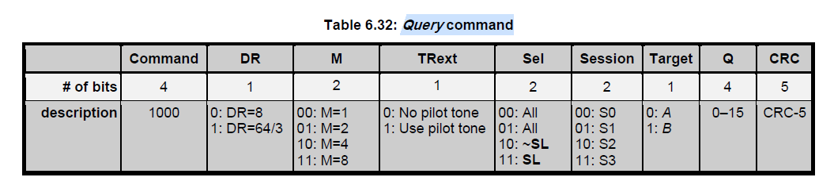

Select Command:

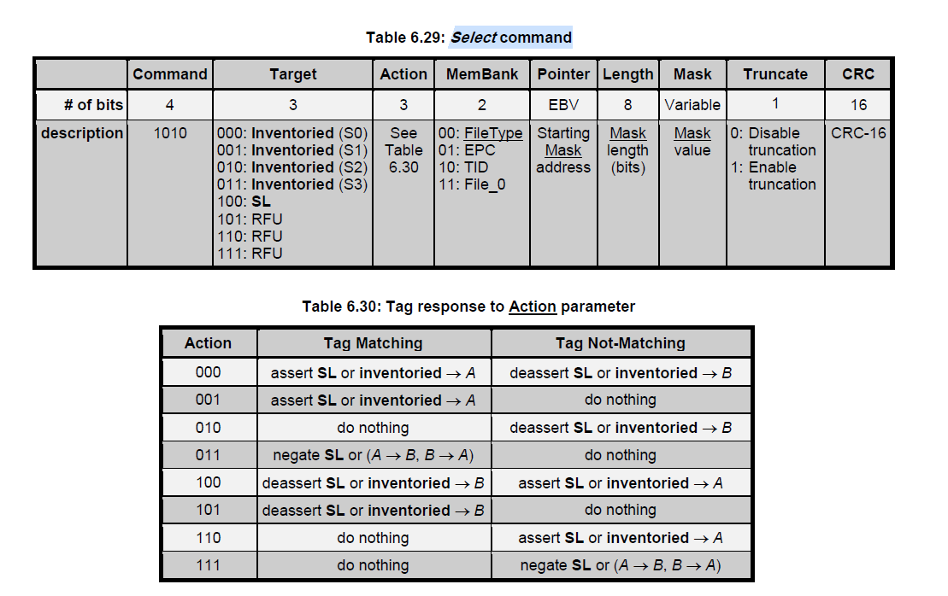

Lock Command:
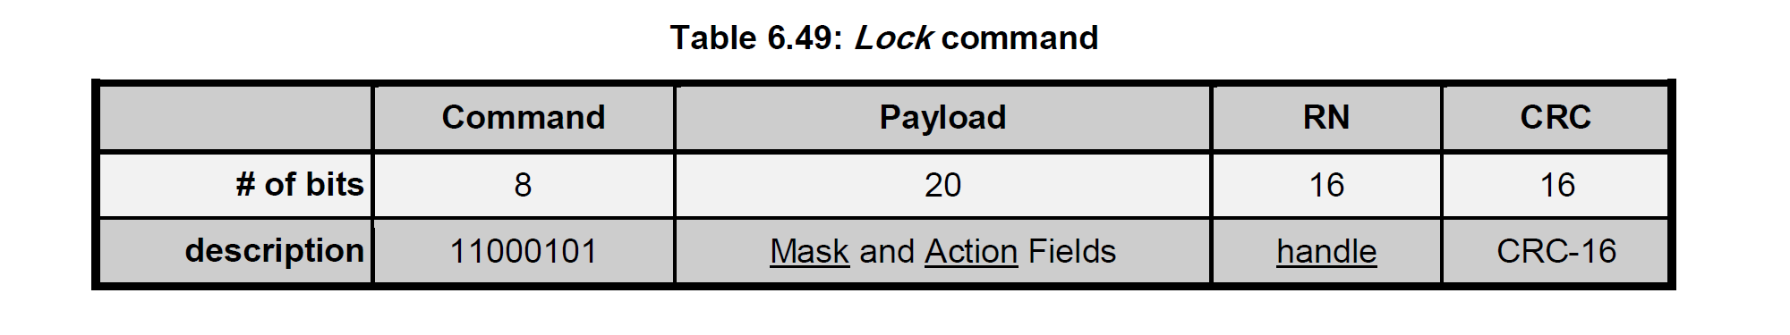
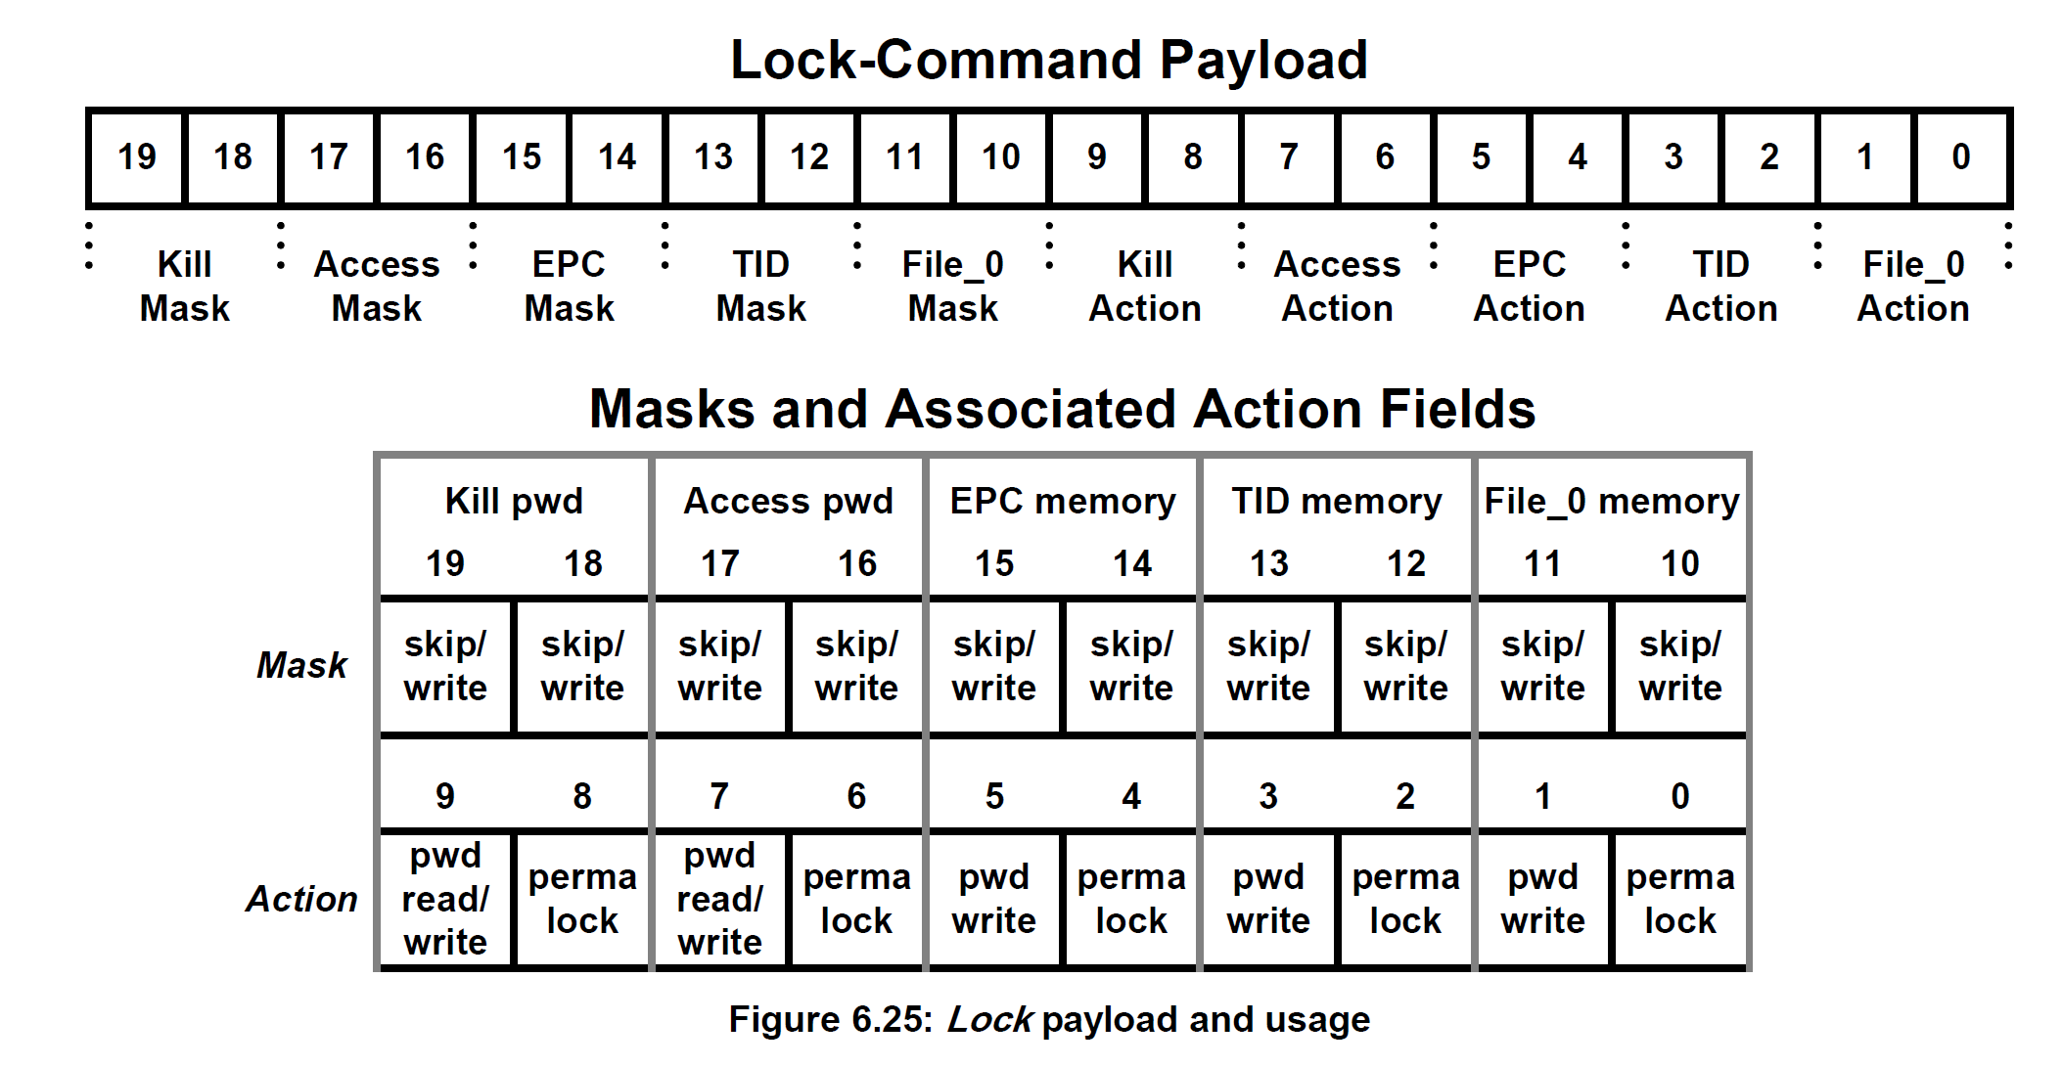
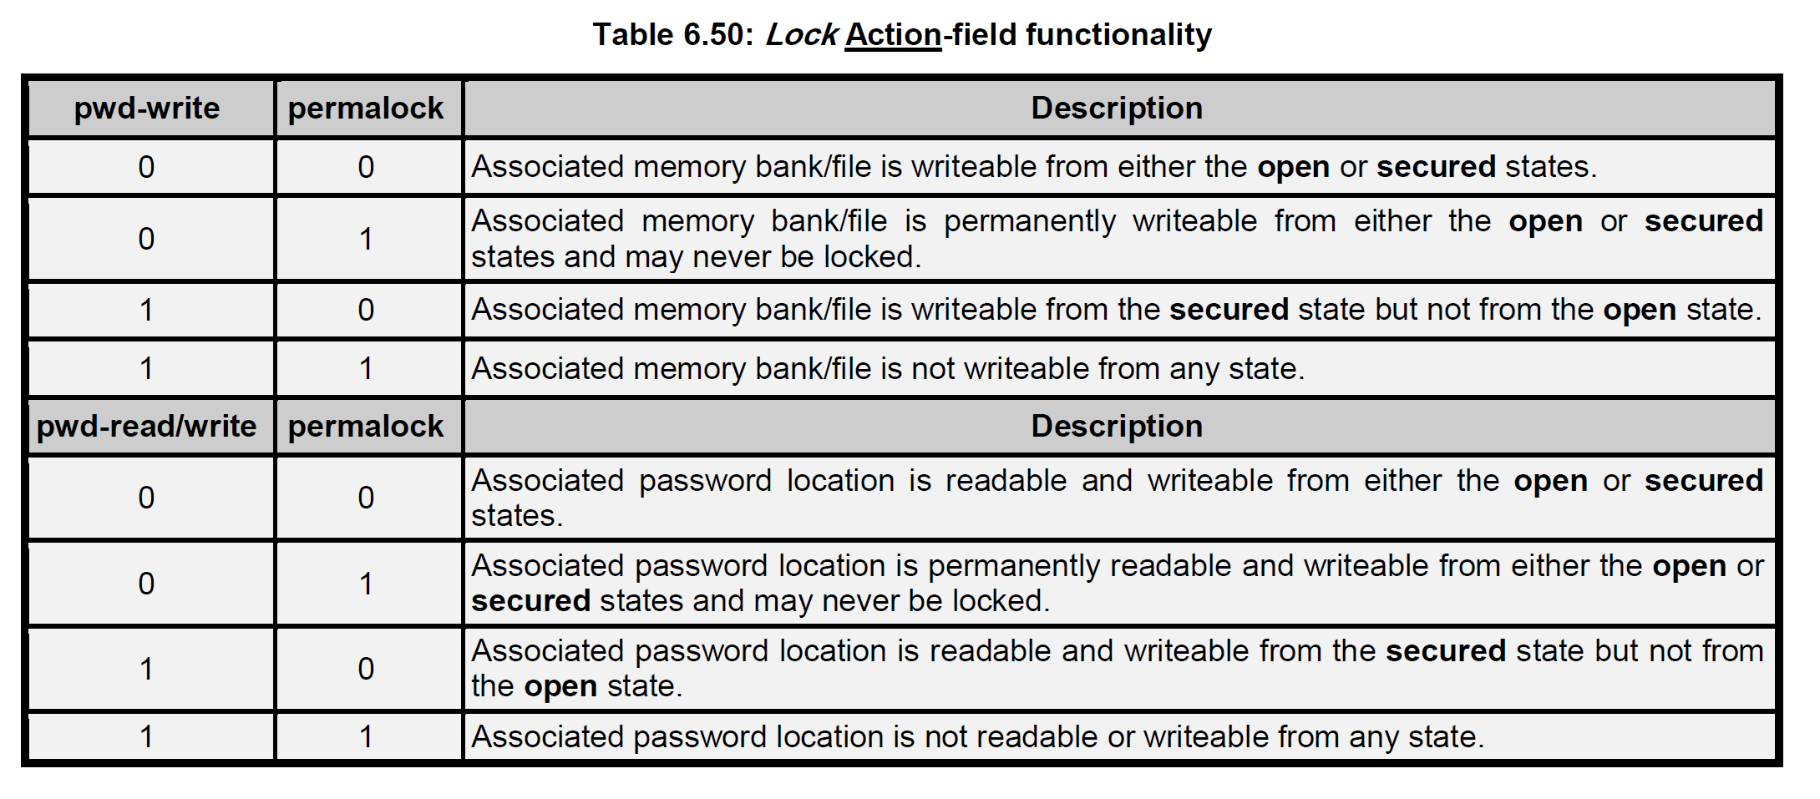

Authenticate Command:

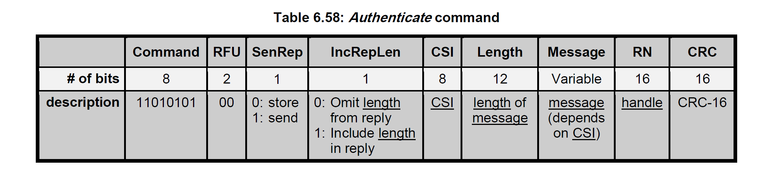

A.3.4 CSL Ex10 Country Enum Table

Country | CSL E710 Country Enum | CSL E710 Country Name | CSL Reader Model Code (Region Code) | Frequency Channel # | Fixed or Hop | Hop Time or  On Time | Off Time | Channel separation | First Channel | Last Channel | Note
Albania | 1 | Albania1 | -1 | 4 | Fixed | 1000 msec | 103 msec | 600 KHz | 865.7 MHz | 867.5 MHz
 | 2 | Albania2 | -2 RW | 23 | Hop | 200 msec |  | 250 KHz | 915.25 MHz | 920.75 MHz | 915-921 MHz
Algeria | 3 | Algeria1 | -1 | 4 | Fixed | 1000 msec | 103 msec | 600 KHz | 871.6 MHz | 873.4 MHz | 870-876 MHz
 | 4 | Algeria2 | NA | 4 | Fixed | 1000 msec | 103 msec | 600 KHz | 881.6 MHz | 883.4 MHz | 880-885 MHz
 | 5 | Algeria3 | -9 | 4 | Fixed | 1000 msec |  | 1200 KHz | 916.3 MHz | 919.9 MHz | 915-921 MHz
 | 6 | Algeria4 | -7 | 2 | Fixed | 1000 msec | 103 msec | 500 KHz | 925.25 MHz | 925.75 MHz | 925-926 MHz
Argentina | 7 | Argentina | -2 RW | 50 | Hop | 200 msec |  | 500 KHz | 902.75 MHz | 927.25 MHz
Armenia | 8 | Armenia | -1 | 4 | Fixed | 1000 msec | 103 msec | 600 KHz | 865.7 MHz | 867.5 MHz
Australia | 9 | Australia1 | -2 AS | 10 | Hop | 200 msec |  | 500 KHz | 920.75 MHz | 925.25 MHz
 | 10 | Australia2 | -2 AS | 14 | Hop | 200 msec |  | 500 KHz | 918.75 MHz | 925.25 MHz
Austria | 11 | Austria1 | -1 | 4 | Fixed | 1000 msec | 103 msec | 600 KHz | 865.7 MHz | 867.5 MHz
 | 12 | Austria2 | -9 | 4 | Fixed | 1000 msec |  | 1200 KHz | 916.3 MHz | 919.9 MHz | 915-921 MHz
Azerbaijan | 13 | Azerbaijan | -1 | 4 | Fixed | 1000 msec | 103 msec | 600 KHz | 865.7 MHz | 867.5 MHz
Bahrain | 14 | Bahrain | -1 | 4 | Fixed | 1000 msec | 103 msec | 600 KHz | 865.7 MHz | 867.5 MHz
Bangladesh | 15 | Bangladesh | -1 | 4 | Fixed | 1000 msec | 103 msec | 600 KHz | 865.7 MHz | 867.5 MHz
Belarus | 16 | Belarus | -1 | 4 | Fixed | 1000 msec | 103 msec | 600 KHz | 865.7 MHz | 867.5 MHz
Belgium | 17 | Belgium1 | -1 | 4 | Fixed | 1000 msec | 103 msec | 600 KHz | 865.7 MHz | 867.5 MHz
 | 18 | Belgium2 | -9 | 4 | Fixed | 1000 msec |  | 1200 KHz | 916.3 MHz | 919.9 MHz | 915-921 MHz
Bolivia | 19 | Bolivia | -2 | 50 | Hop | 200 msec |  | 500 KHz | 902.75 MHz | 927.25 MHz
Bosnia and Herzegovina | 20 | Bosnia | -1 | 4 | Fixed | 1000 msec | 103 msec | 600 KHz | 865.7 MHz | 867.5 MHz
Botswana | 21 | Botswana | -1 | 4 | Fixed | 1000 msec | 103 msec | 600 KHz | 865.7 MHz | 867.5 MHz
Brazil | 22 | Brazil1 | -2 RW | 9 | Fixed | 1000 msec | 103 msec | 500 KHz | 902.75 MHz | 906.75 MHz
 | 23 | Brazil2 | -2 RW | 24 | Fixed | 1000 msec | 103 msec | 500 KHz | 915.75 MHz | 927.25 MHz
Brunei Darussalam | 24 | Brunei1 | -1 | 4 | Fixed | 1000 msec | 103 msec | 600 KHz | 865.7 MHz | 867.5 MHz
 | 25 | Brunei2 | -7 | 7 | Fixed | 1000 msec | 103 msec | 250 KHz | 923.25 MHz | 924.75 MHz | 923 - 925 MHz
Bulgaria | 26 | Bulgaria1 | -1 | 4 | Fixed | 1000 msec | 103 msec | 600 KHz | 865.7 MHz | 867.5 MHz
 | 27 | Bulgaria2 | -9 | 4 | Fixed | 1000 msec |  | 1200 KHz | 916.3 MHz | 919.9 MHz | 915-921 MHz
Cambodia | 28 | Cambodia | -7 | 16 | Hop | 200 msec |  | 250 KHz | 920.625 MHz | 924.375 MHz
Cameroon | 29 | Cameroon | -1 | 4 | Fixed | 1000 msec | 103 msec | 600 KHz | 865.7 MHz | 867.5 MHz
Canada | 30 | Canada | -2 | 50 | Hop | 200 msec |  | 500 KHz | 902.75 MHz | 927.25 MHz
Chile | 31 | Chile1 | -2 RW | 3 | Fixed | 1000 msec | 103 msec | 1200 KHz | 916.3 MHz | 918.7 MHz
 | 32 | Chile2 | -2 RW | 24 | Hop | 200 msec |  | 500 KHz | 915.75 MHz | 927.25 MHz
 | 33 | Chile3 | -2 RW | 4 | Hop | 200 msec |  | 500 KHz | 925.75 MHz | 927.25 MHz
China | 34 | China | -7 | 8 | Hop | 200 msec |  | 500 KHz | 920.625 MHz | 924.125 MHz
Colombia | 35 | Colombia | -2 RW | 50 | Hop | 200 msec |  | 500 KHz | 902.75 MHz | 927.25 MHz
Congo, Rep. | 36 | Congo | -1 | 4 | Fixed | 1000 msec | 103 msec | 600 KHz | 865.7 MHz | 867.5 MHz
Costa Rica | 37 | CostaRica | -2 RW | 50 | Hop | 200 msec |  | 500 KHz | 902.75 MHz | 927.25 MHz
Côte d'Ivoire | 38 | Cotedlvoire | -1 | 4 | Fixed | 1000 msec | 103 msec | 600 KHz | 865.7 MHz | 867.5 MHz
Croatia | 39 | Croatia | -1 | 4 | Fixed | 1000 msec | 103 msec | 600 KHz | 865.7 MHz | 867.5 MHz
Cuba | 40 | Cuba | -2 RW | 50 | Hop | 200 msec |  | 500 KHz | 902.75 MHz | 927.25 MHz
Cyprus | 41 | Cyprus1 | -1 | 4 | Fixed | 1000 msec | 103 msec | 600 KHz | 865.7 MHz | 867.5 MHz
 | 42 | Cyprus2 | -9 | 4 | Fixed | 1000 msec |  | 1200 KHz | 916.3 MHz | 919.9 MHz | 915-921 MHz
Czech Republic | 43 | Czech1 | -1 | 4 | Fixed | 1000 msec | 103 msec | 600 KHz | 865.7 MHz | 867.5 MHz
 | 44 | Czech2 | -9 | 4 | Fixed | 1000 msec |  | 1200 KHz | 916.3 MHz | 919.9 MHz | 915-921 MHz
Denmark | 45 | Denmark1 | -1 | 4 | Fixed | 1000 msec | 103 msec | 600 KHz | 865.7 MHz | 867.5 MHz
 | 46 | Denmark2 | -9 | 4 | Fixed | 1000 msec |  | 1200 KHz | 916.3 MHz | 919.9 MHz | 915-921 MHz
Dominican Republic | 47 | Dominican | -2 RW | 50 | Hop | 200 msec |  | 500 KHz | 902.75 MHz | 927.25 MHz
Ecuador | 48 | Ecuador | -2 RW | 50 | Hop | 200 msec |  | 500 KHz | 902.75 MHz | 927.25 MHz
Egypt, Arab Rep. | 49 | Egypt | -1 | 4 | Fixed | 1000 msec | 103 msec | 600 KHz | 865.7 MHz | 867.5 MHz
El Salvador | 50 | ElSalvador | -2 RW | 50 | Hop | 200 msec |  | 500 KHz | 902.75 MHz | 927.25 MHz
Estonia | 51 | Estonia | -1 | 4 | Fixed | 1000 msec | 103 msec | 600 KHz | 865.7 MHz | 867.5 MHz
Finland | 52 | Finland1 | -1 | 4 | Fixed | 1000 msec | 103 msec | 600 KHz | 865.7 MHz | 867.5 MHz
 | 53 | Finland2 | -9 | 4 | Fixed | 1000 msec |  | 1200 KHz | 916.3 MHz | 919.9 MHz | 915-921 MHz
France | 54 | France | -1 | 4 | Fixed | 1000 msec | 103 msec | 600 KHz | 865.7 MHz | 867.5 MHz
Georgia | 55 | Georgia | -1 | 4 | Fixed | 1000 msec | 103 msec | 600 KHz | 865.7 MHz | 867.5 MHz
Germany | 56 | Germany | -1 | 4 | Fixed | 1000 msec | 103 msec | 600 KHz | 865.7 MHz | 867.5 MHz
Ghana | 57 | Ghana | -1 | 4 | Fixed | 1000 msec | 103 msec | 600 KHz | 865.7 MHz | 867.5 MHz
Greece | 58 | Greece | -1 | 4 | Fixed | 1000 msec | 103 msec | 600 KHz | 865.7 MHz | 867.5 MHz
Guatemala | 59 | Guatemala | -2 RW | 50 | Hop | 200 msec |  | 500 KHz | 902.75 MHz | 927.25 MHz
Hong Kong, China | 60 | HongKong1 | -1 | 4 | Fixed | 1000 msec | 103 msec | 600 KHz | 865.7 MHz | 867.5 MHz
 | 61 | HongKong2 | -2 OFCA | 50 | Hop | 200 msec |  | 50 KHz | 921.25 MHz | 923.7 MHz
Hungary | 62 | Hungary1 | -1 | 4 | Fixed | 1000 msec | 103 msec | 600 KHz | 865.7 MHz | 867.5 MHz
 | 63 | Hungary2 | -9 | 4 | Fixed | 1000 msec |  | 1200 KHz | 916.3 MHz | 919.9 MHz | 915-921 MHz
Iceland | 64 | Iceland | -1 | 4 | Fixed | 1000 msec | 103 msec | 600 KHz | 865.7 MHz | 867.5 MHz
India | 65 | India | -1 | 4 | Fixed | 1000 msec | 103 msec | 600 KHz | 865.7 MHz | 867.5 MHz
Indonesia | 66 | Indonesia | -7 | 4 | Hop | 200 msec |  | 500 KHz | 923.75 MHz | 924.25 MHz
Iran, Islamic Rep. | 67 | Iran | -1 | 4 | Fixed | 1000 msec | 103 msec | 600 KHz | 865.7 MHz | 867.5 MHz
Ireland | 68 | Ireland1 | -1 | 4 | Fixed | 1000 msec | 103 msec | 600 KHz | 865.7 MHz | 867.5 MHz
 | 69 | Ireland2 | -9 | 4 | Fixed | 1000 msec |  | 1200 KHz | 916.3 MHz | 919.9 MHz | 915-921 MHz
Israel | 70 | Israel | -9 | 3 | Fixed | 1000 msec |  | 500 KHz | 915.5 MHz | 916.5 MHz
Italy | 71 | Italy | -1 | 4 | Fixed | 1000 msec | 103 msec | 600 KHz | 865.7 MHz | 867.5 MHz
Jamaica | 72 | Jamaica | -2 RW | 50 | Hop | 200 msec |  | 500 KHz | 902.75 MHz | 927.25 MHz
Japan | 73 | Japan4 | -8 JP4 | 4 | Fixed | 1000 msec |  | 1200 KHz | 916.8 MHz | 920.4 MHz
 | 74 | Japan6 | -8 JP6 | 6 | Fixed | 1000 msec | 103 msec | 1200 KHz, 200 KHz Last 2 | 916.8 MHz | 920.8 MHz | LBT carrier sense with Transmission Time Control
Jordan | 75 | Jordan | -1 | 4 | Fixed | 1000 msec | 103 msec | 600 KHz | 865.7 MHz | 867.5 MHz
Kazakhstan | 76 | Kazakhstan | -1 | 4 | Fixed | 1000 msec | 103 msec | 600 KHz | 865.7 MHz | 867.5 MHz
Kenya | 77 | Kenya | -1 | 4 | Fixed | 1000 msec | 103 msec | 600 KHz | 865.7 MHz | 867.5 MHz
Korea, Rep. | 78 | Korea | -6 | 6 | Hop | 200 msec |  | 600 KHz | 917.3 MHz | 920.3 MHz
Korea (DPR) | 79 | KoreaDPR | -7 | 16 | Hop | 200 msec |  | 250 KHz | 920.625 MHz | 924.375 MHz
Kuwait | 80 | Kuwait | -1 | 4 | Fixed | 1000 msec | 103 msec | 600 KHz | 865.7 MHz | 867.5 MHz
Kyrgyz Republic | 81 | Kyrgyz | -1 | 4 | Fixed | 1000 msec | 103 msec | 600 KHz | 865.7 MHz | 867.5 MHz
Latvia | 82 | Latvia | -1 | 4 | Fixed | 1000 msec | 103 msec | 600 KHz | 865.7 MHz | 867.5 MHz
Lebanon | 83 | Lebanon | -1 | 4 | Fixed | 1000 msec | 103 msec | 600 KHz | 865.7 MHz | 867.5 MHz
Libya | 84 | Libya | -1 | 4 | Fixed | 1000 msec | 103 msec | 600 KHz | 865.7 MHz | 867.5 MHz
Liechtenstein | 85 | Liechtenstein1 | -1 | 4 | Fixed | 1000 msec | 103 msec | 600 KHz | 865.7 MHz | 867.5 MHz
 | 86 | Liechtenstein2 | -9 | 4 | Fixed | 1000 msec |  | 1200 KHz | 916.3 MHz | 919.9 MHz | 915-921 MHz
Lithuania | 87 | Lithuania1 | -1 | 4 | Fixed | 1000 msec | 103 msec | 600 KHz | 865.7 MHz | 867.5 MHz
 | 88 | Lithuania2 | -9 | 4 | Fixed | 1000 msec |  | 1200 KHz | 916.3 MHz | 919.9 MHz | 915-921 MHz
Luxembourg | 89 | Luxembourg1 | -1 | 4 | Fixed | 1000 msec | 103 msec | 600 KHz | 865.7 MHz | 867.5 MHz
 | 90 | Luxembourg2 | -9 | 4 | Fixed | 1000 msec |  | 1200 KHz | 916.3 MHz | 919.9 MHz | 915-921 MHz
Macao, China | 91 | Macao | -7 | 16 | Hop | 200 msec |  | 250 KHz | 920.625 MHz | 924.375 MHz
Macedonia, FYR | 92 | Macedonia | -1 | 4 | Fixed | 1000 msec | 103 msec | 600 KHz | 865.7 MHz | 867.5 MHz
Malaysia | 93 | Malaysia | -7 | 6 | Hop | 200 msec |  | 500 KHz | 919.75 MHz | 922.25 MHz
Malta | 94 | Malta1 | -1 | 4 | Fixed | 1000 msec | 103 msec | 600 KHz | 865.7 MHz | 867.5 MHz
 | 95 | Malta2 | -9 | 4 | Fixed | 1000 msec |  | 1200 KHz | 916.3 MHz | 919.9 MHz | 915-921 MHz
Mauritius | 96 | Mauritius | -1 | 4 | Fixed | 1000 msec | 103 msec | 600 KHz | 865.7 MHz | 867.5 MHz
Mexico | 97 | Mexico | -2 | 50 | Hop | 200 msec |  | 500 KHz | 902.75 MHz | 927.25 MHz
Moldova | 98 | Moldova1 | -1 | 4 | Fixed | 1000 msec | 103 msec | 600 KHz | 865.7 MHz | 867.5 MHz
 | 99 | Moldova2 | -9 | 4 | Fixed | 1000 msec |  | 1200 KHz | 916.3 MHz | 919.9 MHz | 915-921 MHz
Mongolia | 100 | Mongolia | -7 | 16 | Hop | 200 msec |  | 250 KHz | 920.625 MHz | 924.375 MHz
Montenegro | 101 | Montenegro | -1 | 4 | Fixed | 1000 msec | 103 msec | 600 KHz | 865.7 MHz | 867.5 MHz
Morocco | 102 | Morocco | -1 | 4 | Fixed | 1000 msec | 103 msec | 600 KHz | 865.7 MHz | 867.5 MHz
Netherlands | 103 | Netherlands | -1 | 4 | Fixed | 1000 msec | 103 msec | 600 KHz | 865.7 MHz | 867.5 MHz
New Zealand | 104 | NewZealand1 | -1 | 4 | Hop | 200 msec |  | 500 KHz | 864.75 MHz | 867.25 MHz
 | 105 | NewZealand2 | -2 NZ | 14 | Hop | 200 msec |  | 500 KHz | 920.75 MHz | 927.25 MHz
Nicaragua | 106 | Nicaragua | -2 RW | 50 | Hop | 200 msec |  | 500 KHz | 902.75 MHz | 927.25 MHz
Nigeria | 107 | Nigeria | -1 | 4 | Fixed | 1000 msec | 103 msec | 600 KHz | 865.7 MHz | 867.5 MHz
Norway | 108 | Norway1 | -1 | 4 | Fixed | 1000 msec | 103 msec | 600 KHz | 865.7 MHz | 867.5 MHz
 | 109 | Norway2 | -9 | 4 | Fixed | 1000 msec |  | 1200 KHz | 916.3 MHz | 919.9 MHz | 915-921 MHz
Oman | 110 | Oman | -1 | 4 | Fixed | 1000 msec | 103 msec | 600 KHz | 865.7 MHz | 867.5 MHz
Pakistan | 111 | Pakistan | -1 | 4 | Fixed | 1000 msec | 103 msec | 600 KHz | 865.7 MHz | 867.5 MHz
Panama | 112 | Panama | -2 RW | 50 | Hop | 200 msec |  | 500 KHz | 902.75 MHz | 927.25 MHz
Paraguay | 113 | Paraguay | -2 RW | 50 | Hop | 200 msec |  | 500 KHz | 902.75 MHz | 927.25 MHz
Peru | 114 | Peru | -2 RW | 24 | Hop | 200 msec |  | 500 KHz | 915.75 MHz | 927.25 MHz
Philippines | 115 | Philippines | -2 RW | 8 | Hop | 200 msec |  | 250 KHz | 918.125 MHz | 919.875 MHz
Poland | 116 | Poland | -1 | 4 | Fixed | 1000 msec | 103 msec | 600 KHz | 865.7 MHz | 867.5 MHz
Portugal | 117 | Portugal | -1 | 4 | Fixed | 1000 msec | 103 msec | 600 KHz | 865.7 MHz | 867.5 MHz
Romania | 118 | Romania | -1 | 4 | Fixed | 1000 msec | 103 msec | 600 KHz | 865.7 MHz | 867.5 MHz
Russian Federation | 119 | Russia1 | -1 | 4 | Fixed | 1000 msec | 103 msec | 600 KHz | 866.3 MHz | 867.5 MHz | 2 W ERP
 | 120 | Russia3 | -9 | 4 | Fixed | 1000 msec |  | 1200 KHz | 916.3 MHz | 919.9 MHz | 1 W ERP
Senegal | 121 | Senegal | -1 | 4 | Fixed | 1000 msec | 103 msec | 600 KHz | 865.7 MHz | 867.5 MHz
Serbia | 122 | Serbia | -1 | 4 | Fixed | 1000 msec | 103 msec | 600 KHz | 865.7 MHz | 867.5 MHz
Singapore | 123 | Singapore1 | -1 | 4 | Fixed | 1000 msec | 103 msec | 600 KHz | 865.7 MHz | 867.5 MHz
 | 124 | Singapore2 | -2 SG | 8 | Hop | 200 msec |  | 500 KHz | 920.75 MHz | 924.25 MHz
Slovak Republic | 125 | Slovak1 | -1 | 4 | Fixed | 1000 msec | 103 msec | 600 KHz | 865.7 MHz | 867.5 MHz
 | 126 | Slovak2 | -9 | 4 | Fixed | 1000 msec |  | 1200 KHz | 916.3 MHz | 919.9 MHz | 915-921 MHz
Slovenia | 127 | Slovenia1 | -1 | 4 | Fixed | 1000 msec | 103 msec | 600 KHz | 865.7 MHz | 867.5 MHz
 | 128 | Solvenia2 | -9 | 4 | Fixed | 1000 msec |  | 1200 KHz | 916.3 MHz | 919.9 MHz | 915-921 MHz
South Africa | 129 | SouthAfrica1 | -1 | 4 | Fixed | 1000 msec | 103 msec | 600 KHz | 865.7 MHz | 867.5 MHz
 | 130 | SouthAfrica2 | -9 | 4 | Fixed | 1000 msec |  | 1200 KHz | 916.3 MHz | 919.9 MHz | 915-921 MHz
Spain | 131 | Spain | -1 | 4 | Fixed | 1000 msec | 103 msec | 600 KHz | 865.7 MHz | 867.5 MHz
Sri Lanka | 132 | SriLanka | -1 | 4 | Fixed | 1000 msec | 103 msec | 600 KHz | 865.7 MHz | 867.5 MHz
Sudan | 133 | Sudan | -1 | 4 | Fixed | 1000 msec | 103 msec | 600 KHz | 865.7 MHz | 867.5 MHz
Sweden | 134 | Sweden1 | -1 | 4 | Fixed | 1000 msec | 103 msec | 600 KHz | 865.7 MHz | 867.5 MHz
 | 135 | Sweden2 | -9 | 4 | Fixed | 1000 msec |  | 1200 KHz | 916.3 MHz | 919.9 MHz | 915-921 MHz
Switzerland | 136 | Switzerland1 | -1 | 4 | Fixed | 1000 msec | 103 msec | 600 KHz | 865.7 MHz | 867.5 MHz
 | 137 | Switzerland2 | -9 | 4 | Fixed | 1000 msec |  | 1200 KHz | 916.3 MHz | 919.9 MHz | 915-921 MHz
Syrian Arab Rep. | 138 | Syria | -1 | 4 | Fixed | 1000 msec | 103 msec | 600 KHz | 865.7 MHz | 867.5 MHz
Taiwan | 139 | Taiwan1 | -4 | 16 | Hop | 200 msec |  | 500 KHz | 920.25 MHz | 927.750 MHz | 1 Watt ERP for Indoor
 | 140 | Taiwan2 | -4 | 16 | Hop | 200 msec |  | 500 KHz | 920.25 MHz | 927.750 MHz | 0.5 Watt ERP for Outdoor
Tajikistan | 141 | Tajikistan | -1 | 4 | Fixed | 1000 msec | 103 msec | 600 KHz | 865.7 MHz | 867.5 MHz
Tanzania | 142 | Tanzania | -1 | 4 | Fixed | 1000 msec | 103 msec | 600 KHz | 865.7 MHz | 867.5 MHz
Thailand | 143 | Thailand | -2 TH | 8 | Hop | 200 msec |  | 500 KHz | 920.75 MHz | 924.25 MHz
Trinidad and Tobago | 144 | Trinidad | -2 RW | 50 | Hop | 200 msec |  | 500 KHz | 902.75 MHz | 927.25 MHz
Tunisia | 145 | Tunisia | -1 | 4 | Fixed | 1000 msec | 103 msec | 600 KHz | 865.7 MHz | 867.5 MHz
Turkey | 146 | Turkey | -1 | 4 | Fixed | 1000 msec | 103 msec | 600 KHz | 865.7 MHz | 867.5 MHz
Turkmenistan | 147 | Turkmenistan | -1 | 4 | Fixed | 1000 msec | 103 msec | 600 KHz | 865.7 MHz | 867.5 MHz
Uganda | 148 | Uganda | -1 | 4 | Fixed | 1000 msec | 103 msec | 600 KHz | 865.7 MHz | 867.5 MHz
Ukraine | 149 | Ukraine | -1 | 4 | Fixed | 1000 msec | 103 msec | 600 KHz | 865.7 MHz | 867.5 MHz
United Arab Emirates | 150 | UAE | -1 | 4 | Fixed | 1000 msec | 103 msec | 600 KHz | 865.7 MHz | 867.5 MHz
United Kingdom | 151 | UK1 | -1 | 4 | Fixed | 1000 msec | 103 msec | 600 KHz | 865.7 MHz | 867.5 MHz
 | 152 | UK2 | -9 | 4 | Fixed | 1000 msec |  | 1200 KHz | 916.3 MHz | 919.9 MHz | 915-921 MHz
United States | 153 | USA | -2 | 50 | Hop | 200 msec |  | 500 KHz | 902.75 MHz | 927.25 MHz
Uruguay | 154 | Uruguay | -2 RW | 50 | Hop | 200 msec |  | 500 KHz | 902.75 MHz | 927.25 MHz
Venezuela, RB | 155 | Venezuela | -2 RW | 50 | Hop | 200 msec |  | 500 KHz | 902.75 MHz | 927.25 MHz
Vietnam | 156 | Vietnam1 | -1 | 3 | Fixed | 1000 msec | 103 msec | 600 KHz | 866.3 MHz | 867.5 MHz | 866-868 MHz
 | 157 | Vietnam2 | -7 | 8 | Hop | 200 msec |  | 500 KHz | 918.75 MHz | 922.25 MHz
Yemen, Rep. | 158 | Yemen | -1 | 4 | Fixed | 1000 msec | 103 msec | 600 KHz | 865.7 MHz | 867.5 MHz
Zimbabwe | 159 | Zimbabwe | -1 | 4 | Fixed | 1000 msec | 103 msec | 600 KHz | 865.7 MHz | 867.5 MHz
Vietnam | 160 | Vietnam3 | -7 | 4 | Hop | 200 msec |  | 500 KHz | 920.75 MHz | 922.25 MHz

Remark: Enum 160 (Vietnam3) is added to Vietnam country.

A.3.5 Reader Mode Table

Mode  ID | Mode Optimization | Intended Region | Forward Link Modulation | Tari  (µs) | BLF  (kHz) | Reverse Link  Modulation | Chip RX Sensitivity (dBm) | Maximum Read Rate (tags/s)
103 | Read Rate | FCC | DSB | 6.25 | 640 | Miller M=1 | -78 | 1000
120 | Read Rate | FCC | DSB | 6.25 | 640 | Miller M=2 | -81 | 700
345 | Read Rate | FCC, ETSI UB | PR_ASK | 7.5 | 640 | Miller M=4 | -84 | 400
302 | Read Rate | All | PR_ASK | 7.5 | 640 | Miller M=1 | -78 | 800
323 | Read Rate | All | PR_ASK | 7.5 | 640 | Miller M=2 | -81 | 550
344 | ETSI UB DRM | All | PR_ASK | 7.5 | 640 | Miller M=4 | -84 | 400
223 | ETSI LB | ETSI | PR_ASK | 15 | 320 | Miller M=2 | -84 | 300
222 | ETSI LB | ETSI | PR_ASK | 20 | 320 | Miller M=2 | -84 | 250
241 | ETSI LB DRM | ETSI | PR_ASK | 20 | 320 | Miller M=4 | -87 | 200
244 | FCC DRM | FCC | PR_ASK | 20 | 250 | Miller M=4 | -88 | 150
285 | Sensitivity | All | PR_ASK | 20 | 160 | Miller M=8 | -93 | 50

A.4 CSL RFID Uplink Packets
RFID Uplink Packets come back from RFID reader module to the host processor to report important information, for example, tag inventory data (tag_read).

Both CSL packets and Impinj packets are sent back to host processor.

Byte Offset(s) | Name | Description
1:0 | Beginning of Packet – 2 byte fixed Header | 0x49DC
3:2 | Packet Code | Packet codes
4 | Sequence Number | 1 byte cyclic sequenced number
6:5 | Length of Packet Payload | Total length of payload (not including CRC)
N:7 (N=7+Payload Length-1) | Packet Payload | See below packet table and packet details

A.4.1 CSL RFID Uplink Packets Summary Table

The following is table of CSL RFID Uplink Packets:

RFID Packet Code | Name | Descriptions
0x3001 | csl_tag_read_epc_only_new | Simple inventory return containing only PC/EPC/CRC of EPC Bank, antenna port, phase
0x3002 | csl_tag_read_epc_only_recurrent | Index only replacing the full PC/EPC/CRC data
0x3003 | csl_tag_read_multibank_new | Multibank inventory return containing Bank 1 PC and EPC plus extra N sets of data from other banks.
0x3004 | csl_tag_read_multibank_recurrent_index_only | Index only replacing the full PC/EPC/CRC data
0x3006 | csl_tag_read_compact | Compact tag return, multiple tags per event, only PC, EPC and RSSI returned.
0x3007 | csl_miscellaneous_event | Contains various events, for example, antenna cycle end, keep alive, CRC error, etc.
0x3008 | csl_operation_complete | Generated at the completion of any operation
0x3009 | csl_access_complete | Generated at the completion of any access (read, write, lock, kill, etc…) command

A.4.2 CSL RFID Uplink Packets Details

csl_tag_read_epc_only_new

Packet Code: 0x3001

Packet Payload:

Offset | Name | Size | Description
0 | UTC Time Stamp | 4 bytes | 32 bit
4 | RSSI | 2 bytes | RSSI of the tag response
6 | rf_phase_begin | 2 bytes | The rf phase of the tag response at the beginning of the packet
8 | rf_phase_end | 2 bytes | The rf phase of the tag response at the end of the packet
10 | Port Number | 1 byte | Antenna Port Number
11 | RESERVE | 2 bytes | Reserve
13 | Tag_Index | 2 bytes | New assigned Tag index
15 | Tag Data | Variable, Depends on PC bits | The PC, EPC of the tag. The host must examine the PC bits to determine the number of bytes to include in the EPC. Typical 96 bit EPC implies PC (2 byte) + EPC (12 byte) = 14 bytes  (Some tags contain XPC as well)  Note that CRC check is done before sending up to host, so that tag with incorrect CRC are removed  If FastID is enabled, TID data will follow the EPC.

From above table, a typical simple 96 bit EPC tag packet would be 29 bytes long.

csl_tag_read_epc_only_recurrent

Packet Code: 0x3002

Packet Payload:

Offset | Name | Size | Description
0 | UTC Time Stamp | 4 bytes | 32 bit
4 | RSSI | 2 bytes | RSSI of the tag response
6 | rf_phase_begin | 2 bytes | The rf phase of the tag response at the beginning of the packet
8 | rf_phase_end | 2 bytes | The rf phase of the tag response at the end of the packet
10 | Port Number | 1 byte | Antenna Port Number
11 | Reserve | 2 bytes | Reserve
13 | Tag_Index | 2 bytes | Tag index

From above table, a EPC tag packet would be 15 bytes long.

csl_tag_read_multibank_new

Packet Code: 0x3003

Packet Payload:

Offset | Name | Size | Description
0 | UTC Time Stamp | 4 bytes | 32 bit
4 | RSSI | 2 bytes | RSSI of the tag reponse
6 | rf_phase_begin | 2 bytes | The rf phase of the tag response at the beginning of the packet
8 | rf_phase_end | 2 bytes | The rf phase of the tag response at the end of the packet
10 | Port Number | 1 byte | Antenna Port number
11 | Reserve | 2 bytes | Reserve
13 | Tag_Index | 2 bytes | New assigned Tag index
15 | EPC Bank Data | Variable, depends on PC bits | The PC, EPC of the tag. The host must examine the PC bits to determine the number of bytes to include in the EPC.
 | Number of Extra Banks | 1 byte | N
 | Extra Bank Index 1 Data | M bytes
 | …..
 | Extra Bank Index N Data | K

csl_tag_read_multibank_recurrent_index_only

Packet Code: 0x3004

Packet Payload:

Offset | Name | Size | Description
0 | UTC Time Stamp | 4 bytes | 32 bit
4 | RSSI | 2 bytes | RSSI of the tag reponse
6 | rf_phase_begin | 2 bytes | The rf phase of the tag response at the beginning of the packet
8 | rf_phase_end | 2 bytes | The rf phase of the tag response at the end of the packet
10 | Port Number | 1 byte | Antenna Port number
11 | Reserve | 2 bytes | Reserved For Future Use
13 | Tag_Index | 2 bytes | Tag index

csl_tag_read_compact

Packet Code: 0x3006

Packet Payload:

Offset | Name | Size | Description
0 | UTC Time Stamp | 4 bytes | 32 bit
4 | Reserve | 2 bytes | Reserve
6 | Tag Data | N bytes | Tag Data: PC, EPC, RSSI (2 bytes)

Where N <= 225

csl_miscellaneous_event

Packet Code: 0x3007

Packet Payload:

Offset | Name | Size | Description
0 | UTC Time Stamp | 4 bytes | 32 bit
4 | Event Code | 2 bytes | Code of the miscellaneous events:  0x0001 = keep alive  0x0002 = inventory round end  0x0003 = CRC error rate (2 bytes Data)  0x0004 = tag rate value (2 bytes Data)
6 | Data | N Bytes

csl_operation_complete

Packet Code: 0x3008

Packet Payload:

Offset | Name | Size | Description
0 | UTC Time Stamp | 4 bytes | 32 bit
4 | Command code | 2 bytes | Command code
6 | Status | 2 bytes | 0x0000 = Success  Error codes references to Appendix B.

csl_access_complete

Packet Code: 0x3009

Packet Payload:

Offset | Name | Size | Description
0 | UTC Time Stamp | 4 bytes | 32 bit
4 | Access command | 2 bytes | 0xC2 = Read  0xC3 = Write  0xC4 = Kill  0xC5 = Lock  0xC6 = Access  0xC7 = Block Write  0xC9 = Block Permalock  0xD5 = Authenticate
6 | Tag error code | 1 byte | 0x00 = Other error  0x01 = Not supported  0x02 = Insufficient privileges  0x03 = Memory overrun  0x04 = Memory locked  0x05 = Crypto suite error  0x06 = Command not encapsulated  0x07 = ResponseBuffer overflow  0x08 = Security timeout  0x0B = Insufficient power  0x0F = Non-specific error  0x10 = No error
7 | Mac error code | 1 bytes | 0x00 = No error  0x01 = No tag reply  0x02 = Invalid password  0x03 = Failed to send command  0x04 = No access reply
8 | Write word count | 2 bytes | The number of words successfully written.
10 | Reserve | 2 bytes | Reserve
12 | Data | Variable | The tag response data if present

Appendix B – Error Codes
The “status” field of the csl_operation_complete packet comes back with error code field.
Code (hex number) | Description
0x0001 | Tag cache table buffer is overflowed.
0x0002 | Wrong register address
0x0003 | Register length too large
0x0004 | E710 not powered up
0x0005 | Invalid parameter
0x0006 | Event fifo full
0x0007 | TX not ramped up
0x0008 | Register read only
0x0009 | Failed to halt
0x000A | PLL not locked
0x000B | Power control target failed
0x000C | Radio power not enabled
0x000D | E710 command error (e.g. battery low)
0x000E | E710 Op timeout
0x000F | E710 Aggregate error (e.g. battery low, metal reflection)
0x0010 | E710 hardware link error
0x0011 | E710 event fail to send error
0x0012 | E710 antenna error (e.g. metal reflection)
0x00FF | Other error (e.g. battery low)

Appendix C: Barcode Reader Command Sequence Examples

C.1 Pre-setup of Barcode Reader
Barcode reader requires presetting it to Trigger Mode once (saving settings in non-volatile memory inside the barcode reader). This is actually done ex-factory and normally not needed to do, unless the barcode reader has been set to other modes by using early version of Apps.

This step is normally NOT required because CS710S has its barcode reader preset to Trigger mode ex-factory.

Step 1: Power on barcode reader using 0x9000 command
Step 2: Use 0x9003 barcode downlink command data API to send the following to CS710S:
nls0006010;
nls0313000=30000;
nls0302000;
nls0006000;
Since 0x9003 can handle 50 bytes of command payload, so the above 4 commands, 50 characters and hence 50 bytes of ascii, can be concatenated and sent down in one shot!!!!
This command will set the barcode reader properly and save that to non-volatile memory. Next time on power up the barcode reader will behave properly - no need to send this again.
Step 3: Power off barcode reader using 0x9001 command

C.2 Normal Operation of Barcode Reader

This is the normal operation step

Step 1: On initial successful connection to CS710S, power on barcode reader using 0x9000 command and leave it on.
Step 2: In barcode reading mode, when the “Start” button or the Trigger button is pressed, use 0x9003 command to send 0x1b, 0x33 down to barcode (only need to send 1 time BT downlink, 2 bytes of payload)
Step 3: In barcode reading mode, when the “Stop” button or the Trigger button is released, use 0x9003 command to send 0x1b, 0x30 down to barcode
Step 4: On final closing of App, then power off the barcode reader using 0x9001 command.

Appendix D – How to Choose Reader Modes

There are 11 reader modes in CS710S and are enumerated as in following table. Only 1 profile is active at any time in CS710S. The purpose of each reader mode is explained below. These purposes correspond to different business case and physical scenarios. The user should try out each profile to see which one gives best performance.

Mode  ID | Mode Optimization | Intended Region | Forward Link Modulation | Tari  (µs) | BLF  (kHz) | Reverse Link  Modulation | Chip RX Sensitivity (dBm) | Maximum Read Rate (tags/s)
103 | Read Rate | FCC | DSB | 6.25 | 640 | Miller M=1 | -78 | 1000
120 | Read Rate | FCC | DSB | 6.25 | 640 | Miller M=2 | -81 | 700
345 | Read Rate | FCC, ETSI UB | PR_ASK | 7.5 | 640 | Miller M=4 | -84 | 400
302 | Read Rate | All | PR_ASK | 7.5 | 640 | Miller M=1 | -78 | 800
323 | Read Rate | All | PR_ASK | 7.5 | 640 | Miller M=2 | -81 | 550
344 | ETSI UB DRM | All | PR_ASK | 7.5 | 640 | Miller M=4 | -84 | 400
223 | ETSI LB | ETSI | PR_ASK | 15 | 320 | Miller M=2 | -84 | 300
222 | ETSI LB | ETSI | PR_ASK | 20 | 320 | Miller M=2 | -84 | 250
241 | ETSI LB DRM | ETSI | PR_ASK | 20 | 320 | Miller M=4 | -87 | 200
244 | FCC DRM | FCC | PR_ASK | 20 | 250 | Miller M=4 | -88 | 150
285 | Sensitivity | All | PR_ASK | 20 | 160 | Miller M=8 | -93 | 50

The following are guidelines for choosing which Reader Mode in the various geographic regions of the world:

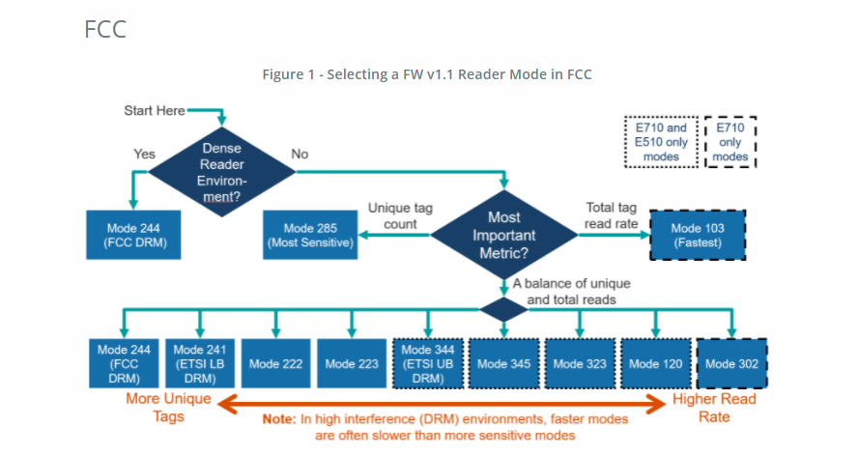

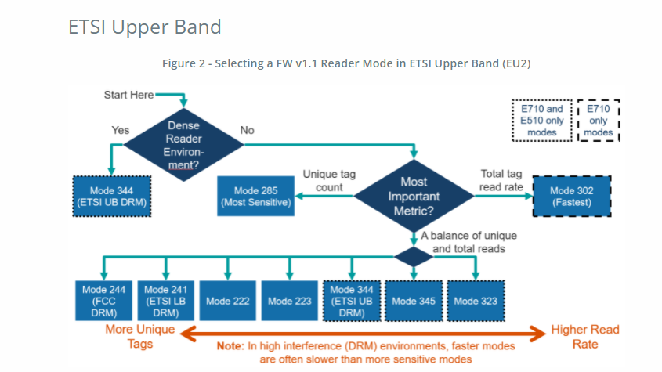

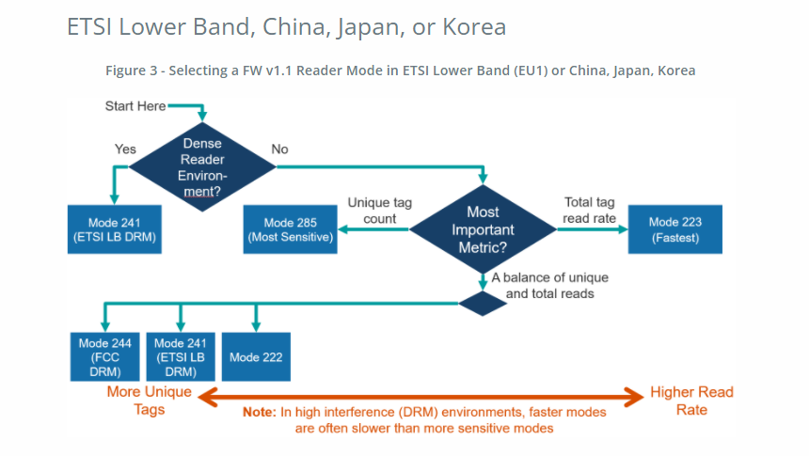

Appendix E – Session
Session is a concept of EPC to allow a tag to respond to multiple readers inventorying it at the same time, each using a different session number.

There are 4 possible sessions: S0, S1, S2, S3.

The user however has to be careful because these 4 sessions have different behavior, notably how the tag flag “persist” in time. A tag, before inventory or when just after power on, has a flag of State A. When it is inventoried, the flag will go to State B. The tag flag will stay in State B until the tag powers off or the persistence time is up.

A reader can declare it only wants to inventory flag A, so that after a tag is inventoried and its flag gone to State B, it will no longer respond to further inventory rounds – until the end of the persistence time.

Now for S0, S1, S2 and S3, the persistence times are DIFFERENT! Because of that, one has to be very careful in choosing which session to use.

Session | Tag Flags Persistence Time
S0 | Tag Energized: indefinite  Tag Not Energized: none
S1 | Tag Energized: 0.5 second < Persistence Time < 5 seconds  Tag Not Energized: 0.5 second < Persistence Time < 5 seconds
S2 | Tag Energized: indefinite  Tag Not Energized: 2 seconds < Persistence Time
S3 | Tag Energized: indefinite  Tag Not Energized: 2 seconds < Persistence Time

Appendix F – Tag Population and Q
Tag Population is the RFID tag population that is to be inventoried. To be more precise, it is the population of tags that can be “seen” by the RFID reader.

Q is an EPC concept related to the way a group of tags is inventoried. When a reader broadcast its desire to inventory tags, it sends out a Q value. The tag will, based on that Q, calculate a certain number and define that as the number of repeated inventories the reader will do. Basically, the relationship of Inventory Repeats and Q is:

Inventory Repeats = 2^{Q}

The tag will then choose by random a certain number less than this Inventory Repeats. When the reader starts doing inventory, the tag will then respond at that repeat number.

In other words, the Inventory Repeats should correspond to Tag Population:

Tag Population = Inventory Repeats = 2^{Q}

For example, if there are 8 tags, then in theory the Q can be 3, and if each tag chooses a number different from that of the other 7 (miraculously, of course), then the 8 tags will be inventoried in an orderly manner in turn.

Of course this will never happen, as the tags will easily choose a number the same as that of another one, and a collision will happen.

Therefore, it is a normal practice to have a bigger Q, such as 4 in this case, so that the 8 tags would have a lower chance of choosing the same number.

Therefore, reversing the equation, ideally, we can have:

Q = INTEGER(LOG₂(Tag Population))

But in reality, we need some headroom, so that:

Q = INTEGER(LOG₂(Tag Population x 2)+1)

Appendix G – Query Algorithm

There are 2 types of Query Algorithm: Fixed Q and Dynamic Q.

For Fixed Q, the Q value does not change. In other words, the expected Tag Population does not change.

For Dynamic Q, the Q value changes adaptively: when there are a lot of inventory repeats where no tags respond, the reader will interpret that there are not that many RFID tags in the front, and hence it is more efficient to change the Q to a smaller value. When there are a lot of inventory repeats where the reader receive data but they do not satisfy checksum, meaning there is heavy collision, then the reader will interpret that there are too many RFID tags in the front of the reader, and hence it is better to increase the value of Q. Dynamic Q algorithm is a way to allow the RFID reader to adapt to different amount of RFID tags being seen by the reader. The idea is that if there are not so many tags, then the Q can be reduced and the reader can collect all the tag data faster.

Appendix H – Target

Target here actually refers to the target flag that the reader wants to inventory. There are 2 possible flags of an RFID tag: State A and State B.

When an RFID tag is first powered up, it has a flag of State A. After it is inventoried, the state of the flag becomes State B.

The tag will only go back to State A if either it is powered off and powered on again, or if its persistence time has run up.

For each round of inventory, the reader sends out notification to the world which tag flag state it wants to inventory. It can keep on inventory State A, or it can inventory State A and State B alternatively from one round of inventory to the next round of inventory.

In theory, it is a good thing to inventory only State A. The reason being that those tags that have been inventoried should not respond again, and will hence quickly reduce the amount of collision between tags. So in general if you set inventory to State A only, the inventory of large amount of tags can be very fast.

The only catch is that when a tag responds to the reader, it does not know another tag is colliding with it. It sends out the response and thinks it has done the job, hence transitioning to flag State B. So in such case, the tag will not respond to further inventory, even though its response has been lost due to collision. Because of that, sometimes the user will set the inventory to target State A in one inventory round, and then State B in the next round, and vice versa, and so on. This is called A/B Toggle or A & B Dual Target or simply Dual Target.

Appendix I – Security

There are 4 actions you can apply on the memory inside an RFID tag:

          - Lock
          - Unlock
          - Permanent Lock
          - Permanent Unlock

You can obtain an EPC Global document which can be downloaded from the EPC GLobal website that explains this:
.
Once there, press the button showing the latest air interface protocol document and click on it to get the pdf file.

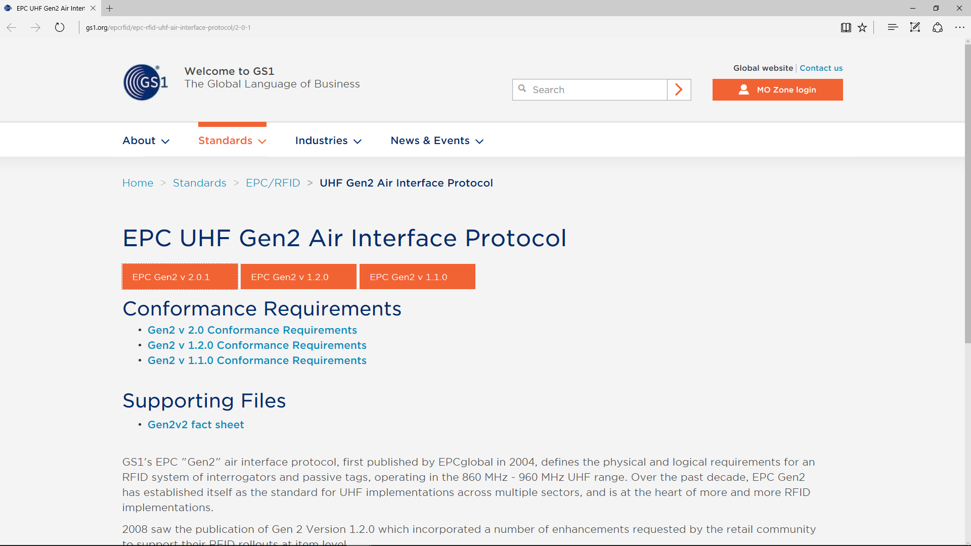
Click the latest Air Interface Protocol document

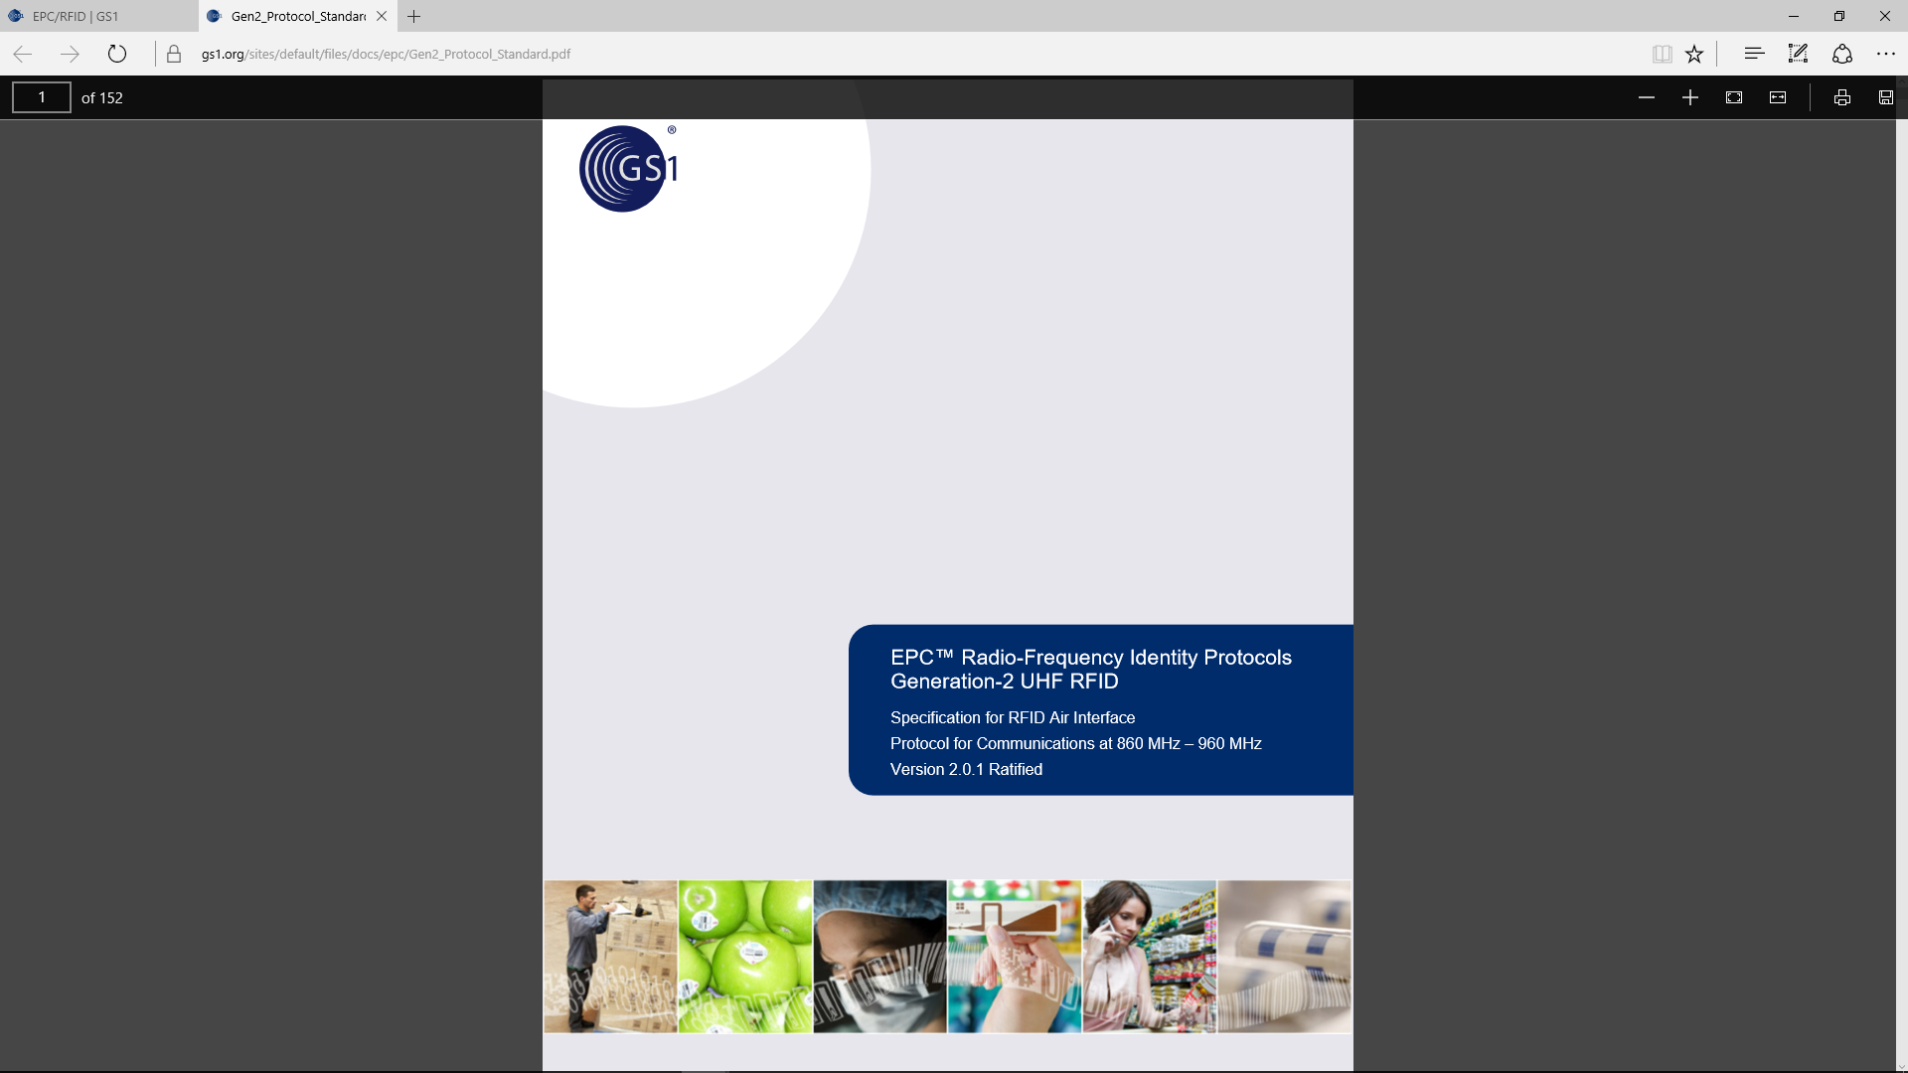

For the Access Password and Kill Password the security locking affects both reading and writing.

For the EPC memory bank and the User memory bank, the security locking affects only writing.

For the TID memory bank, since we are the user and not the manufacturing vendor, there is no security action that can be applied. It has been permanently unlocked in the factory and it cannot be changed.

Appendix J – Tag Focus
Tag Focus is a special feature of Impinj tag IC. When enabled, and when the reader is using Session S1 and Target A to query the tag, the tag will, once inventoried, remain in Flag B until the inventory is completed.

This is in contrast to the normal EPC query using S1 and Target A, where the tag will only remain in Flag B for 2 to 5 seconds – this time being defined as persistence time.

The original purpose of EPC S1 and Target A is so that those tags that have been inventoried before would not come back and be inventoried again so quickly, so that more time slots are available for other tags that have not been inventoried yet. However, the time of 2 to 5 seconds are simply too short if there are many tags in the environment being illuminated by the reader. This is particularly true if the reader is “seeing” a whole bunch of tagged items in a warehouse, where there may be more than 1000 tags the reader can “see” at any moment. The end result is before all the tags have been inventoried, the early inventoried tags, having passed 5 seconds after it was first inventoried, join back to be inventoried!!

In the early days of EPC standard, a few hundred tags being inventoried is already a rather unthinkable matter, and so 2 to 5 seconds of persistence time is enough. Nowadays, with the ever improving sensitivity of tags, 5 seconds is not enough.

With Impinj Tag Focus enabled, the tag simply would not respond again until the inventory is completely over.

Appendix K – Models & Regulatory Regions

There are various models, denoted by the alphanumeric key to the right of the dash after the “CS710S-“, here denoted by “N”. The applicable regulatory regions for each model are described below:

N=1: 865-868 MHz for Europe ETSI, Russia, Middle East countries,
865-867 MHz for India
N=2: 902-928 MHz, FCC, for USA, Canada and Mexico. Hopping frequencies locked
N=2 AS: 920-926 MHz, Australia. Hopping frequencies locked
N=2 NZ: 921.5-928 MHz, New Zealand. Hopping frequencies locked
N=2 OFCA: 920-925 MHz, Hong Kong. Hopping frequencies locked
N=2 RW: 920-928 MHz, Rest of the World, e.g. Philippines, Brazil, Peru, Uruguay, etc.
N=4: 922-928 MHz, Taiwan
N=6: 917-920.8 South Korea
N=7: 920-925 MHz, China
N=8: 916.7-920.9 MHz, Japan
N=9: 915-921 MHz, Europe Upper Band

Appendix L – CRC Table/Compute Codes
The following is the CRC lookup table and compute code.

const unsigned int xdata crc_lookup_table[256] =
{
0x0000,0x1189,0x2312,0x329b,0x4624,0x57ad,0x6536,0x74bf,
0x8c48,0x9dc1,0xaf5a,0xbed3,0xca6c,0xdbe5,0xe97e,0xf8f7,
0x1081,0x0108,0x3393,0x221a,0x56a5,0x472c,0x75b7,0x643e,
0x9cc9,0x8d40,0xbfdb,0xae52,0xdaed,0xcb64,0xf9ff,0xe876,
0x2102,0x308b,0x0210,0x1399,0x6726,0x76af,0x4434,0x55bd,
0xad4a,0xbcc3,0x8e58,0x9fd1,0xeb6e,0xfae7,0xc87c,0xd9f5,
0x3183,0x200a,0x1291,0x0318,0x77a7,0x662e,0x54b5,0x453c,
0xbdcb,0xac42,0x9ed9,0x8f50,0xfbef,0xea66,0xd8fd,0xc974,
0x4204,0x538d,0x6116,0x709f,0x0420,0x15a9,0x2732,0x36bb,
0xce4c,0xdfc5,0xed5e,0xfcd7,0x8868,0x99e1,0xab7a,0xbaf3,
0x5285,0x430c,0x7197,0x601e,0x14a1,0x0528,0x37b3,0x263a,
0xdecd,0xcf44,0xfddf,0xec56,0x98e9,0x8960,0xbbfb,0xaa72,
0x6306,0x728f,0x4014,0x519d,0x2522,0x34ab,0x0630,0x17b9,
0xef4e,0xfec7,0xcc5c,0xddd5,0xa96a,0xb8e3,0x8a78,0x9bf1,
0x7387,0x620e,0x5095,0x411c,0x35a3,0x242a,0x16b1,0x0738,
0xffcf,0xee46,0xdcdd,0xcd54,0xb9eb,0xa862,0x9af9,0x8b70,
0x8408,0x9581,0xa71a,0xb693,0xc22c,0xd3a5,0xe13e,0xf0b7,
0x0840,0x19c9,0x2b52,0x3adb,0x4e64,0x5fed,0x6d76,0x7cff,
0x9489,0x8500,0xb79b,0xa612,0xd2ad,0xc324,0xf1bf,0xe036,
0x18c1,0x0948,0x3bd3,0x2a5a,0x5ee5,0x4f6c,0x7df7,0x6c7e,
0xa50a,0xb483,0x8618,0x9791,0xe32e,0xf2a7,0xc03c,0xd1b5,
0x2942,0x38cb,0x0a50,0x1bd9,0x6f66,0x7eef,0x4c74,0x5dfd,
0xb58b,0xa402,0x9699,0x8710,0xf3af,0xe226,0xd0bd,0xc134,
0x39c3,0x284a,0x1ad1,0x0b58,0x7fe7,0x6e6e,0x5cf5,0x4d7c,
0xc60c,0xd785,0xe51e,0xf497,0x8028,0x91a1,0xa33a,0xb2b3,
0x4a44,0x5bcd,0x6956,0x78df,0x0c60,0x1de9,0x2f72,0x3efb,
0xd68d,0xc704,0xf59f,0xe416,0x90a9,0x8120,0xb3bb,0xa232,
0x5ac5,0x4b4c,0x79d7,0x685e,0x1ce1,0x0d68,0x3ff3,0x2e7a,
0xe70e,0xf687,0xc41c,0xd595,0xa12a,0xb0a3,0x8238,0x93b1,
0x6b46,0x7acf,0x4854,0x59dd,0x2d62,0x3ceb,0x0e70,0x1ff9,
0xf78f,0xe606,0xd49d,0xc514,0xb1ab,0xa022,0x92b9,0x8330,
0x7bc7,0x6a4e,0x58d5,0x495c,0x3de3,0x2c6a,0x1ef1,0x0f78
};

// ---------------------------------------------------------------------------
// ComputeCRC
//
// This function computes the CRC returns the 16-bit CRC
// ---------------------------------------------------------------------------
unsigned int ComputeCRC(unsigned char* input, unsigned int length, unsigned int init)
{
unsigned int CRC;
unsigned int i;
CRC = init;
for (i = 0; i < length; i++)
{
CRC = UpdateCRC (CRC, input[i]);
}
return CRC;
}

// ---------------------------------------------------------------------------
// UpdateCRC
//
// This function accepts a CRC argument and a <newbyte> and returns an
// updated CRC value; Uses the CRC Lookup Table
// ---------------------------------------------------------------------------
unsigned int UpdateCRC (unsigned int crc, unsigned char newbyte)
{
unsigned short retval;
unsigned short index;
unsigned short table_value;
index = (crc ^ newbyte) & 0xff ;
table_value = crc_lookup_table[index];
retval = (crc >> 8) ^ table_value;
return retval;
}

